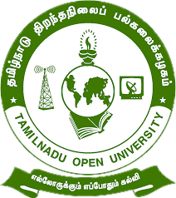

Tamil Nadu Open University
School of Continuing Education

jkpo;ehL jpwe;jepiyg; gy;fiyf;fofk;
njhlh; fy;tpf;fhdg; gs;;sp

Programme Project Report (PPR)

Vocational Diploma in Refrigeration and AC Technician (VDRA)

Members of the Board of Studies [BOS]
of School of Continuing Education

S.No. | Name | Designation
1 | Dr. P. Thiyagarajan | Professor & Director  School of Continuing Education  Tamil Nadu Open University,  Chennai
2 | Dr. K. Devan | Professor & Centre Head  Centre for Adult and Continuing Education,  Pondicherry University,  R.V. Nagar, Puducherry
3 | Dr. V.P. Matheswaran | Professor & Head  Department of Adult & Continuing Education,  University of Madras,  Chepauk, Chennai
4 | Dr. S. Jayalakshmi | Assistant Professor  DDU-KAUSHAL Kendra,  Bharathidasan University,  Tiruchirappalli
5 | Mr.S.Vendan | Managing Director  Vendan Visual Effects,  Thirvanmiyur, Chennai
6 | Ms.C.Rohini Chandrasekaran | Consultant  Fair Labour Associations,  Tirupur, Tamil Nadu
7 | Mr. R. Thiyagarajan | Junior Instructor  IIDA Community College,  No.38,Bharathi Nagar Main Road,  Zamin Pallavaram, Chennai
8 | Mrs. V. Rubini | Nurse, Health Centre  Tamil Nadu Open University, Chennai
9 | Er. R. Meenambigai | Assistant Professor  School of Continuing Education  Tamil Nadu Open University,  Chennai
10 | Dr. I. Ambeth | Assistant Professor & Regional Director i/c  Madurai Regional Centre,  Tamil Nadu Open University,  Madurai

Tamil Nadu Open University
School of Continuing Education
Vocational Diploma in Refrigeration and AC Technician (VDRA) Programme Project Report (PPR)
(a). Programme’s Mission & Objectives: The main Objectives of the Vocational Diploma in Refrigeration and Air-Conditioning (AC) Technician Programme is to train the learners for the job of a AC Mechanic, AC & Refrigerator maintenance mechanic, AC Servicing technician, Commercial coolers service mechanic and also building the key competencies amongst the learner.
(b).Relevance of the Programme with HEI’s Mission and Goals : Tamil Nadu Open University one of Mission and Goal is to encourage Skill Development to empower the human resource through Participatory Education System and accordingly the Vocational Diploma Programme has been developed. The Programme is being offered under flexible skill training mode.
(c). Nature of prospective target group of learners: Candidates who wish to seek employment in the RAC industry particularly the young boys, slum dwellers, unskilled workers employed in the mechanic field, rural dwellers, unemployed youths and minorities.
(d). Appropriateness of programme to be conducted in Open and Distance Learning mode to acquire specific skills and Competence: Apart from ODL Mode, the Programme also has been designed to offer under Flexible Skill Training mode. Refrigeration and AC Technician are to trouble shoot AC & Refrigerator, identify the problem and rectify the same, perform regular maintenance and servicing of AC. To acquire Specific Skill, the Core Skills, Generic Skills and Professional Skills component are also included.
(e). Instructional Design: The Curriculum and the Syllabi are designed by covering all the aspect of refrigeration and air-conditioning. The duration of the Programme is One Year and it will be offered both English and Tamil Medium. Required Faculties working in the Community Colleges will handle classes for the Vocational Diploma Programme in Refrigeration and AC Technician. The Programme will be delivered through Community Colleges of Tamil Nadu Open University which is having required faculties and support staff. The Credit System suggested by Distance Education Bureau i.e., 32 Credits for One Year Diploma has been assigned. Print, Audio and Video materials also will be developed for the Programme.
(f).Procedure for Admissions, Curriculum Transaction and Evaluation: The admission for the Refrigeration and AC Technician Programme will be carried out through on-line by Tamil Nadu Open University and the Counselling and Practical classes will be conducted through Constituent Community College and Community Colleges of Tamil Nadu Open University. The hands on training will be provided in the Industries and mobile Lab. The evaluation will be carried by Tamil Nadu Open University consists of Continuous Internal Assessment through Spot Assignment and External Assessment through Term End Examination.
(i).Eligibility: Candidates who have passed in the 10th Standard Examinations or its equivalent as per Tamil Nadu Government Order No-163 dated 22-05-2008.
(ii).Fee Structure: Rs.4,200/- (plus Registration of Charges).
(g) Requirement of the laboratory support and Library Resources: Lab Facilities are made available in Constituent Community Colleges and Community Colleges of Tamil Nadu Open University as per requirement as given in the National Skill Development Corporation(NSDC), Qualification Pack(QP). Practical Manual developed by the Tamil Nadu Open University will be supplied to the Students apart from Self Learning Materials. Library Books are available at the Headquarters, Regional Centres and Constituent Community Colleges and Community Colleges of Tamil Nadu Open University.
(i). Quality Assurance Mechanism and Expected Programme Outcomes: Tamil Nadu Open University through its Centre for Internal Quality Assurance (CIQA) will monitor the delivering aspect of Constituent Community Colleges and community Colleges of TNOU for maintaining quality. Feedback will be collected from the Learners and success story if any will also be shared with learners. After completion of Refrigeration and AC Technician Programme, Learner will acquire the Core Skills, Generic Skills and Professional Skills components and will be employed in the automobile Industry.
Proposed Programme Structure of Vocational Diploma in Refrigeration & AC Technician
S.No | Course Code | Course Title | Credits | Marks Distribution
 |  |  |  | Internal | External | Total
1 | VDRA-1 | Refrigerator and Refrigeration | 4 | 30 | 70 | 100
2 | VDRA -2 | Air Conditioner and Air Conditioning | 4 | 30 | 70 | 100
3 | VDRA -3 | Special Cooling Systems | 4 | 30 | 70 | 100
4 | VDRA -P1 | Refrigerator Servicing (Practical) | 4 | 30 | 70 | 100
5 | VDRA -P2 | AC Servicing (Practical) | 4 | 30 | 70 | 100
6 | LCS | Life Coping Skills | 6 | 30 | 70 | 100
7 | CNS | Communication Skills | 6 | 30 | 70 | 100
Total |  |  | 32 | 210 | 490 | 700
Age: 15 years and above
Duration of Programme: 1 year and maximum of 3 years
Credits: Credits in Open and Distance Learning (ODL) is nothing but study hours. The following are explanation for Credit in ODL System.
- One Credit would mean equivalent of 30 hours of study.
- Learners are expected to allot 24 hours for reading the Self Learning Materials supplied by the University, 3 hours for viewing the video and listening to audio and 3 hours for writing assignments to complete one credit in ODL.
Examination System: Examination to Vocational Diploma Programme in Refrigeration and AC Technician is designed to maintain quality of standard. Theory will be conducted by the University in the identified Examination Centres. For the Spot Assignment students may be permitted to write with the help of books/materials for each Course, which will be evaluated by the Evaluators appointed by the University.
Assignment (Internal): Assignment carries 30 marks, consists of descriptive type of questions for each Course (3 X 10 = 30 Marks). Learners are expected to write 10-15 pages for each assignment. Submission of Assignment is compulsory.
Theory Examination (External): Students shall normally be allowed to appear for Theory Examination by completing Practical and Assignment. The Term-End Examination shall carry Section- A, Section- B and Section- C
Section-A | Three out of Five Short Answer Questions [Each 3- Marks] | 3 X 3 = 9 Marks
Section-B | Three out of Five Long Answer Questions [Each 7- Marks] | 3 X 7 = 21 Marks
Section-C | Four out of Seven Essay questions of which one will be Multiple Choice Question  [Each 10-marks] | 4 X 10 = 40 Marks
Total |  | 70 Marks
Passing Minimum: The passing minimum is 35 percent in the internal and external/ theory examination and overall 40 per cent for successful completion of each course.
Classification of Successful Candidate: Candidates who pass all the Courses and who secure 60 per cent and above in the aggregate of marks will be placed in the First Class. Those securing 50 per cent and above but below 60 per cent in the aggregate will be placed in the Second Class. Those securing 40 per cent and above but below 50 per cent in the aggregate will be placed in the Third Class.

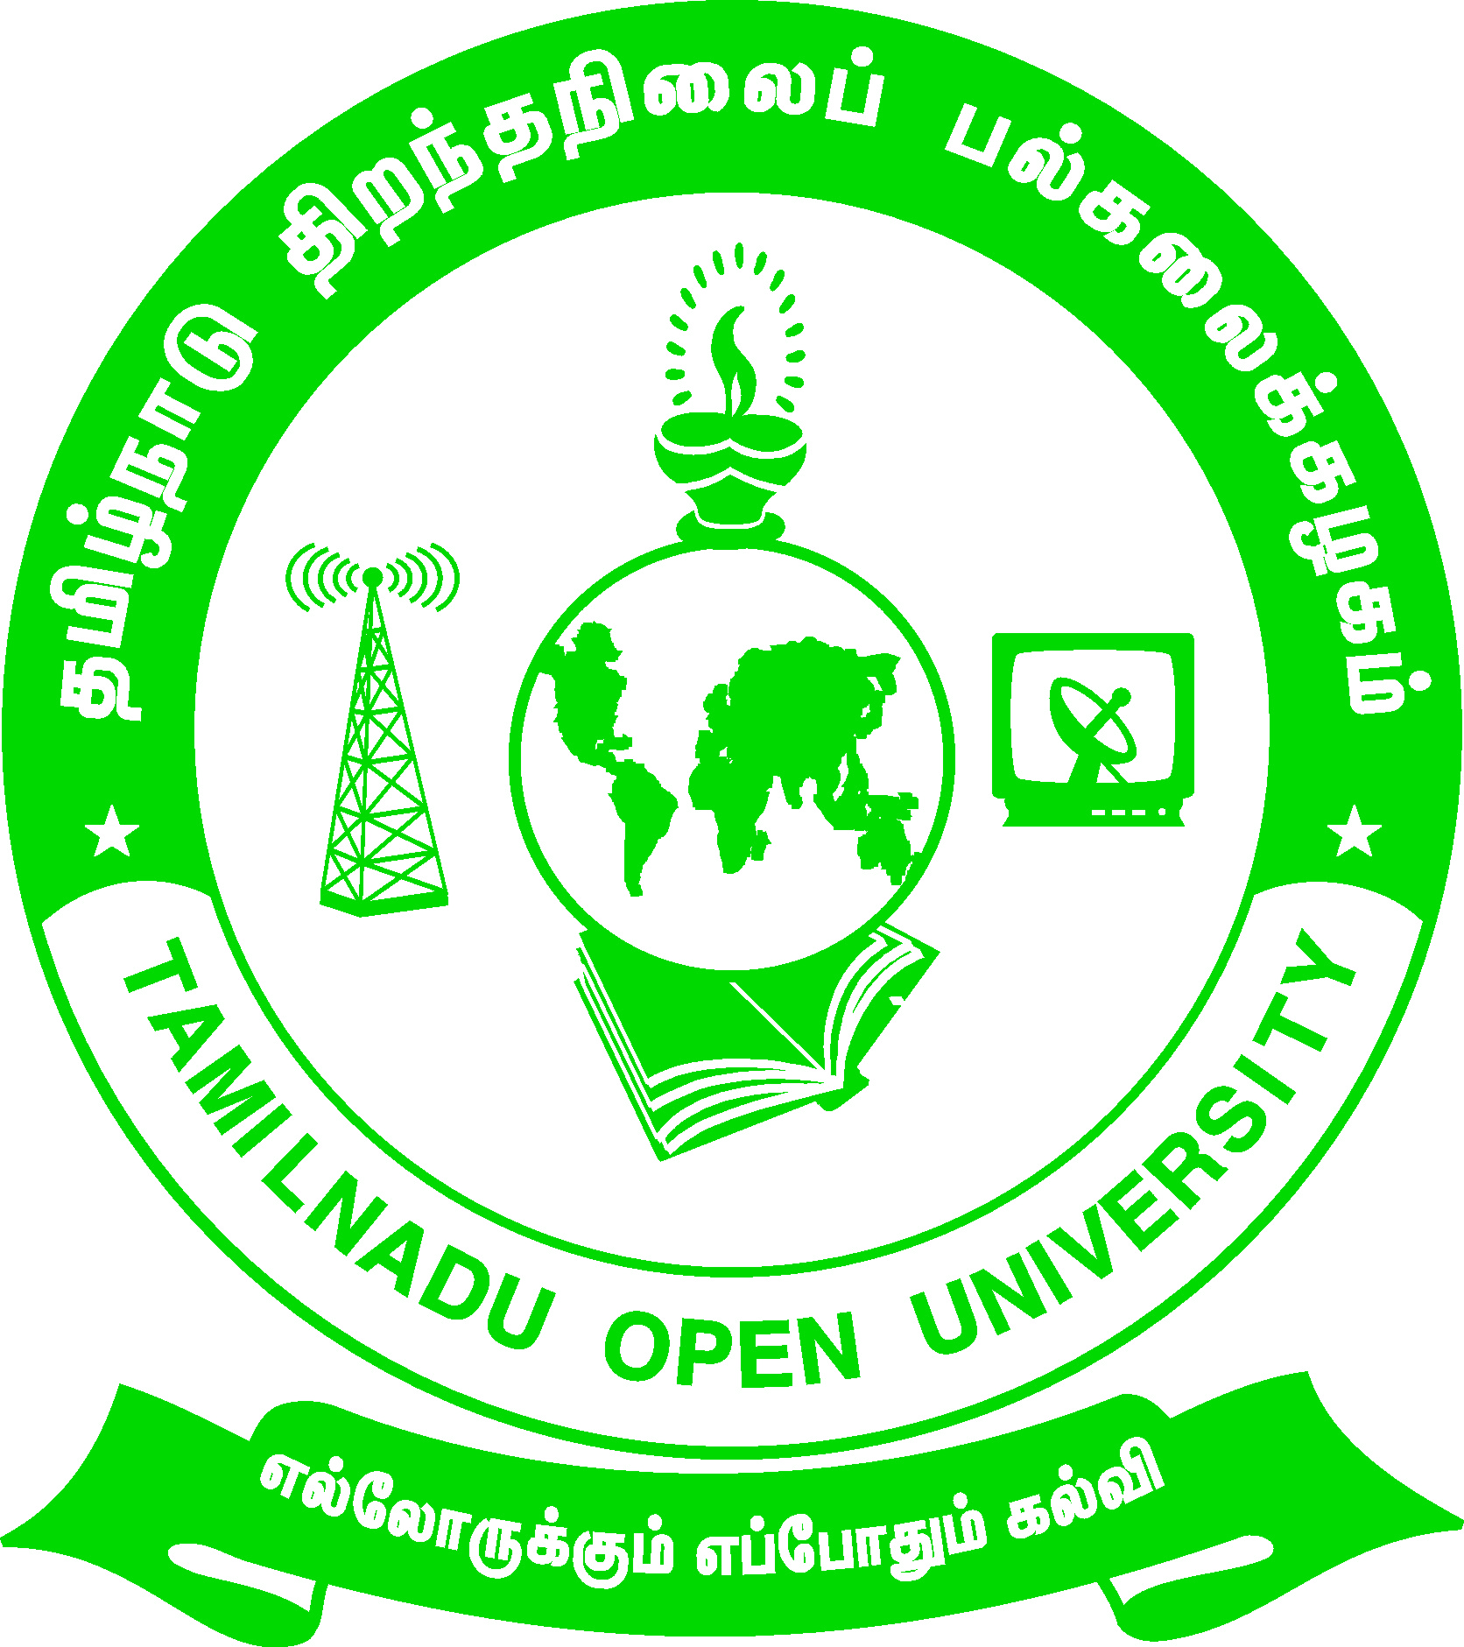 | Tamil Nadu Open University  School of Continuing Education  Chennai – 15
Name of the Programme– Vocational Diploma in Refrigeration & AC Technician - Syllabus (Flexible Skill Training Mode)
Course Title | : | Refrigerator and Refrigeration
Course Code | : | VDRA-1
Course Credit | : | 4
Course Objectives
While studying the Refrigerator and Refrigeration, the student shall be able to:
- Explains the basics of refrigeration and the types of refrigeration
- Elaborates the major components of Refrigerator
- Describes the types of refrigerants used in refrigerator
- Elaborates about the maintenance and trouble shooting of refrigerator
- Enumerates the step by step procedure of repairing and servicing of refrigerator and its parts
Course Outcomes
After completion of the Course Refrigerator and Refrigeration, the student will be able to:
- Define the laws of Thermodynamics
- Elaborate the various refrigeration cycles and the process of refrigeration
- Identify and enumerate about the major parts of refrigerator namely compressor, evaporator, condenser etc.
- List the characteristics of an ideal refrigerant
- Demonstrate the procedure of care, maintenance, repair and servicing of various parts of refrigerator
Block-1: Basics of Refrigeration
Unit-1 – Fundamentals of Refrigeration
Introduction - Basic Terminology – Thermodynamics - Laws of Thermodynamics
Unit-2: Refrigeration Cycles
Process of Refrigeration - Methods of Producing Low Temperature - Air Cycle Refrigeration - Vapour Compression Cycle of Refrigeration - Vapour Absorption Cycle
Block-2: Major Components of Refrigerator
Unit -3: Components of Refrigeration System
Compressor – Condenser – Evaporator - Expansion Devices
Unit -4: Refrigerants
Introduction - Refrigerant Criteria - Designation of Refrigerants - Types of Refrigerants - Properties of Ideal Refrigerant
Block-3: Maintenance and Trouble-Shooting of Refrigerator
Unit -5: Care and Maintenance of Refrigerator
Basic Safety Precautions - External parts of a Refrigerator - Installation Process - Refrigerator with water and Ice Dispenser - Care of Refrigerator - Maintenance of Refrigerator - Maintenance of Freezer
Unit -6: Trouble-Shooting of Refrigerator
Technical Safety - Problems of Refrigerator - Trouble shooting the Refrigerator
Block-4: Testing and Servicing of Refrigerator
Unit -7: Basic Electrical Circuits of Automobile
Testing and Replacing of the Refrigerator Parts - Servicing of Refrigerator Parts
Unit -8: Refrigerant Charging and Leakage Tests
Charging of Refrigerant - Effects of Undercharging the Refrigerant Level in a refrigeration equipment - Refrigerant Leak Test

Tamil Nadu Open University
School of Continuing Education
Chennai – 15
Name of the Programme– Vocational Diploma in Refrigeration and AC Technician - Syllabus (Flexible Skill Training Mode)
Course Title | : | Air-Conditioner and Air-Conditioning
Course Code | : | VDRA-2
Course Credit | : | 4
Course Objectives
While studying the Air-Conditioner and Air-Conditioning, the student shall be able to:
- Describe the Principle of air-conditioning and the science behind air-conditioning
- Classify the air-conditioning systems and study the various components of the system
- Calculate the energy efficiency of the window and split air-conditioner
- Acquire knowledge about the tools used for copper tubing and installation of AC
- Demonstrate the duct work of AC, servicing and installation of units
Course Outcomes
After completion of the Course Air-Conditioner and Air-Conditioning, the student will be able to:
- State the need and application of air-conditioning
- Identify the major control systems of air-conditioner
- Perform Copper tubing operations including brazing
- Installation of widow and split ac, ducting work of central AC
- Perform installation, servicing and maintenance of air-conditioner
Block-1: Science of Air-Conditioning
Unit -1: Basics of Air-conditioning
Introduction - History of Air-Conditioning - Types of System - Need for Air-Conditioning - Application of Air Conditioning - Principles of Air Conditioning
Unit -2: Air-Conditioning Systems
Introduction to Air-conditioning system - Classification of Air-conditioning system - Types of Coolers - Major system components - Major system controls
Block-2: Working of AC and Copper Tubing
Unit -3: Working of AC and Energy Efficiency
Types of Air-Conditioning unit - Energy Efficiency - Energy Labelling Standard for Air-Conditioner - Working of Window Air Conditioner (WAC) - Working of Split Air Conditioner (SAC)
Unit -4: Tubes, Equipments and Copper Tubing Operations
Hand Tools - Equipments and Devices - Copper Tubing - Copper Tubing Operations
Block-3: Installations and Ducting
Unit -5: Installation of Window and Split Air-Conditioner
General Safety for Installation - Installation of Window AC - Installation of Split AC - Post Installation Check-up
Unit: Duct Work
Types of Duct Work - Components of Duct Work - Balancing the System - Duct Liner - Duct Cleaning
Block-4: Servicing and Maintenance of Air-Conditioner
Unit -7: Servicing of Air-Conditioner
Basic servicing operations of Air-conditioner - Avoiding Contaminants - Good service Practices - General Guidelines for Good Service Practices - Recovery, Recycling and Reclamation of Refrigerants - Cleaning of Water cooled Condensers
Unit -8: Safety and Maintenance of Air-Conditioner
Safety and its Importance - Safety while working on Air-conditioners - First Aid for injuries to Technicians - Quality Maintenance of Tools and Equipments - Preventive Maintenance of Room Air-conditioners - Maintenance of Cooling Coil

Tamil Nadu Open University
School of Continuing Education
Chennai – 15
Name of the Programme– Vocational Diploma in Refrigeration and AC Technician - Syllabus (Flexible Skill Training Mode)
Course Title | : | Special Cooling Systems
Course Code | : | VDRA-3
Course Credit | : | 4
Course Objectives
While studying the Special Cooling Systems, the student shall be able to:
- Enumerate the types of special cooling system and the refrigerant used
- Describe about deep freezers, bottle coolers and display cabinets
- Explain about various refrigerated vehicles and cold storages used for food storage
- Theorize about ice cream freezers, fish freezers and white ice plant
Course Outcomes
After completion of the Course Special Cooling Systems, the student will be able to:
- List the various special cooling systems
- Demonstrate the maintenance of deep freezers
- Explain the working of white ice plant
- Detail the application of cold storage and its maintenance
Block-1: Types Of Special Cooling System and Deep Freezers
Unit -1 – Cooling Systems
Introduction - Special Cooling Systems - Refrigerant
Unit -2: Deep Freezers
History of Freezing - Types of Freezers - Basic Feerzerology - Application of Deep Freezer - Maintenance of Freezers
Block-2: Beverage Coolers and Display Cabinets
Unit -3: Bottle Coolers and Chillers
Bottle Coolers and its Types - Components of a Bottle Cooler - Rapid Chillers - Using Rapid Drink Chillers - Blast Chillers - Benefits and Disadvantages of Blast Chillers
Unit -4: Refrigerated Display Cabinets
Display Counters - Multi-deck Refrigerators - Chiller Doors - Care and Maintenance of a Refrigerated Cabinet
Block-3: Cold Storage and Refrigerated Vehicles
Unit -5: Cold Room and Cold Storage
Cold room and its types - Cold storage plant - Working of Cold Storage Plant - Applications of Cold Storage
Unit -6: Transport Refrigeration
Transport Refrigeration Systems - Types of Refrigerated Transport - Refrigerated Containers/ Reefer - Bus Air-Conditioning
Block-4: Consumable Products Freezer
Unit -7: Ice Cream and Fisheries Freezer
Types of Ice Cream Freezers - Freezing Ice Cream - Batch Freezers - Continuous Ice Cream Freezers - Operating the Continuous Freezers - Fisheries Freezers
Unit -8: White Ice Plant
White Ice and its Types - Requirements of Ice Plant - Working Principle - Applications of White Ice

Tamil Nadu Open University
School of Continuing Education
Chennai – 15
Name of the Programme– Vocational Diploma in Refrigeration & AC Technician - Syllabus (Flexible Skill Training Mode)
Course Title | : | Refrigerator Servicing(Practical)
Course Code | : | VDRA-P1
Course Credit | : | 4
This practical course deals with the following basic techniques:
- Tube cutting and bending
- Flaring, swagging
- Brazing
- Wire joining process
- Connecting load protector and thermostat
- Dismantling and assembling of different types of compressors
- Servicing of different types of compressors
- Servicing of the components of a refrigerator like condenser, receiver, evaporator, lubrication system
- Maintenance of all the components of a refrigerator like condenser, receiver, evaporator, lubrication system
- Servicing of water cooler, deep freezer, white ice plant
- Servicing of cold storage, beverage/ bottle cooler

Tamil Nadu Open University
School of Continuing Education
Chennai – 15
Name of the Programme– Vocational Diploma in Refrigeration & AC Technician - Syllabus (Flexible Skill Training Mode)
Course Title | : | AC Servicing(Practical)
Course Code | : | VDRA-P2
Course Credit | : | 4
This practical course deals with the following basic techniques:
- Servicing of all the components of a air conditioning like condenser, receiver; evaporator, lubrication system
- Maintenance of all the components of a air conditioning like condenser, receiver; evaporator, lubrication system
- Servicing of window air conditioning
- Servicing of split AC
- Servicing of central plant AC
- Servicing of Inverter AC
- Ducting – different types for central plant AC

Tamil Nadu Open University
School of Continuing Education
Chennai – 15
Life Coping Skills (LCS) and Communication Skills (CNS)-Core Course for all Vocational Diploma Programmes
Life Coping Skills and Communication Skills have been included to help the students to understand the meaning of life and to understand the meaning of relationship and how we communicate in every day life.
Examination System: Examination to Life Coping Skills and Communication Skills are designed to maintain quality of standard. Theory will be conducted by the University in the identified Examination Centres. For the Spot Assignment students may be permitted to write with the help of books/materials for each Course, which will be evaluated by the Evaluators appointed by the University.
Assignment (Internal): Assignment carries 30 marks, consists of descriptive type of questions for each Course (3 X 10 = 30 Marks). Learners are expected to write 10-15 pages for each assignment. Submission of Assignment is compulsory.
Theory Examination (External): Students shall normally be allowed to appear for Theory Examination by completing Practical and Assignment. The Term-End Examination shall carry Section- A, Section- B and Section- C
Section-A | Three out of Five Short Answer Questions [Each 3- Marks] | 3 X 3 = 9 Marks
Section-B | Three out of Five Long Answer Questions [Each 7- Marks] | 3 X 7 = 21 Marks
Section-C | Four out of Seven Essay questions of which one will be Multiple Choice Question  [Each 10-marks] | 4 X 10 = 40 Marks
Total |  | 70 Marks
Passing Minimum: The passing minimum is 35 percent in the internal and external/ theory examination taken together for successful completion of each course.

Tamil Nadu Open University
School of Continuing Education
Chennai – 15
Name of the Course – Life Coping Skills - Syllabus (Flexible Skill Training Mode)
Course Title | : | Life Coping Skills
Course Code | : | LCS
Course Credit | : | 6
(1).Life Coping Skills : The main objectives of the Life Coping skills is to understand the meaning of life and its challenges, provide skills and knowledge needed to cope with life’s problems and challenges, develop a positive attitude, train to be successful and useful citizens through positive thinking, cope with criticism, failure, anger, loneliness, physical and verbal abuse, improve self-esteem, manage time and stress, develop one’s personality to its full potential, help the students to become team players, develop personal skills and to provide skill problems solving and decision making.
Block- 1-Self Skills
Unit-1: Self Skill – I
Meaning and Process of Coping- Restructuring the Life Story - External and Internal Influences in One's Life - Messages: Positive and Negative - Life Illustrations - Self Esteem - Self Concept - Self Acceptance - Self Actualisation- Personality Development
Unit-2: Self Skill – II
Positive Thinking - Goal Setting - Problem Solving - Decision Making
Block- 2: Social and Leadership Skills
Unit-3: Social Skills
Social Skills- Motivation- De-motivating Factor- Meaning and Attitude to Success- Time Management -The Management of Time is the Management of Life - How to gain an extra mile every day- Tips for Time Management - Stress Management
Unit-4: Leadership Skills
Emergence of a Leader -Characteristics of Leadership -Various kinds of Leaders -What should Leader do- The Moulding of a Leader - Characteristics of a Successful Leader- Team Work - What is it like work in a Team- What is Team Learning
Unit-5: Coping Skills – I
What is Shyness- How to Overcome Shyness- Tips to Overcome Shyness - Coping with Loneliness-Finding Ways to Change the Feelings of Loneliness-Overcoming Loneliness - Tips to Overcome Loneliness- Coping with Depression - Coping with Fear- Coping with Anger and Verbal Abuse -Verbal Abuse- Coping with Failure - Coping with Criticism
Unit-6: Coping Skills – II
Coping with HIV – AIDS- Coping with Alcoholism - Tobacco and Smoking - Coping with Substance Abuse
Block -4: Managerial and Entrepreneur Skills
Unit-7: Managerial Skills
Coping with Conflict- Conflict can be Constructive or Destructive- Constructive Nature of Conflicts- What are the Strategies for Managing Conflicts- Tactics of Conflict Management- Coping with Change- Twelve Steps to Implement Change
Unit-8: Entrepreneur Skills
Career Guidance - Career Planning- Preparation for Employment- Looking for Opportunities - Preparation for the Interview - Work Environment - Thriving in Today's Work Environment .

Tamil Nadu Open University
School of Continuing Education
Chennai – 15
Name of the Course – Communication Skills - Syllabus (Flexible Skill Training Mode)
Course Title | : | Communication Skills
Course Code | : | CNS
Course Credit | : | 6
(2).Communication Skills: The main objectives of the Communication Skills is to introduce to the students the process and kinds of communication, train the students to code and decode communication effectively, explain the various interpersonal skills required to interact with others and make the students understand the meaning of relationship and how we communicate in every day life.
Block -1: Communication
Unit-1: Introduction to Communication
Communication concept- Process of Communication- Elements of Communication- Types of Messages- Types of Communication- Speech- Different Types of Verbal Communication-Effective Communication-Interpersonal Communication- Communication as Skilled Behaviour-Social Skills Model- Social Skills Model to Interpersonal Communication-Implications of the Approach-Components of Interpersonal Skills-Characteristics of a Good Conversation-Hints for Inter-Personal Relation-Ship
Unit-2: Effective Communication
Definition of Effective Communication- Common Forms of Communication- The Positive Value of Good Communication- Guidelines for Effective Communication- Review Questions- Three Principles of Communication- Communication Strategies
Block- 2:Situational and Behavioural Communication
Unit-3: Situational Language
Greeting and Introducing- Inviting Someone and Making Requests- Offering Help and Seeking Permission- Asking for Advice and Expressing Gratitude-Asking whether Someone Remembers- Persuading, Complimenting and Congratulating- Expressing Sympathy- Complaining and Apologising- Making Suggestions and Warning Someone- Asking for Excuse and Ending a Conversation- Asking for Information and Someone's Opinion- Asking if someone is sure and to Say Something Again- Checking that you have understood- Asking whether someone knows- Asking About Possibility and Preference- Requesting Someone- Asking if someone Agrees- Asking if someone is Obliged to do something- Some Useful Expressions- Different Models of Situational Conversations
Unit-4: Behavioural Communication
Effective Criticism Made Easy: Basic Rules for Delivering-Negative Feedback to Others- Before Delivering to Negative Feedback- While Delivering Negative Feedback- After Delivering Negative Feedback
Block -3: Types and Modes of Communication
Unit-5: Modes of Communication
Group Discussion- Importance of Group Testing- Factors that Contribute to Group-Worthiness- Guidelines for Group Discussion- Factors that Matter in a Group Discussion- Important Parameters in Group Discussion- Types of Groups- Speech- Speech Distractions- Five ways to make your Audience Sit Up- Successful Public Speaking- Drafting a Speech- Major Pitfalls in Public Speaking- Body Language- The Constituents of Body Language
Unit-6: Leadership and Team Communication
Definition of a Leadership- Types of Leadership- Shared Leadership- Ten Principles for Leadership Communication- Styles of Leadership- Team Communication- Achieving Effectiveness through Team Communication- The Components of Communication- Characteristics of Highly Cohesive Teams
Block- 4:Interview Skills and English Language
Unit-7: Interview Skills
Interview Defined- Kinds of Interviews- Preparation for a Job Interview- Telephonic Interview- Preparation for a Telephonic Interview- Speaking to Foreigners- Success in Interview-Ten Most Frequently Asked Questions- Inter Whew- Inter Phew
Unit-8: English as Spoken and Written Language
Simple Sentence- Word Order- Modals- Passive Voice- Letter Writing-An Informal Letter-Formal Letter-Personal Letters- Official Letters- Paragraph Writing- Essay Writing- Types of Essay- Prose Comprehension- Poetry Comprehension- Precise Writing- Dialogues.

