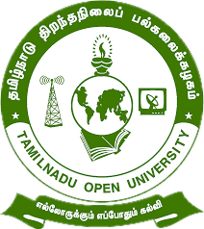

Tamil Nadu Open University
School of Continuing Education

jkpo;ehL jpwe;jepiyg; gy;fiyf;fofk;
njhlh; fy;tpf;fhdg; gs;;sp

Programme Project Report (PPR)

Vocational Diploma in Beautician (VDIB)

Members of the Board of Studies [BOS]
of School of Continuing Education

S.No. | Name | Designation
1 | Dr. P. Thiyagarajan | Professor & Director  School of Continuing Education  Tamil Nadu Open University,  Chennai
2 | Dr. K. Devan | Professor & Centre Head  Centre for Adult and Continuing Education,  Pondicherry University,  R.V. Nagar, Puducherry
3 | Dr. V.P. Matheswaran | Professor & Head  Department of Adult & Continuing Education,  University of Madras,  Chepauk, Chennai
4 | Dr. S. Jayalakshmi | Assistant Professor  DDU-KAUSHAL Kendra,  Bharathidasan University,  Tiruchirappalli
5 | Mr.S.Vendan | Managing Director  Vendan Visual Effects,  Thirvanmiyur, Chennai
6 | Ms.C.Rohini Chandrasekaran | Consultant  Fair Labour Associations,  Tirupur, Tamil Nadu
7 | Mr. R. Thiyagarajan | Junior Instructor  IIDA Community College,  No.38,Bharathi Nagar Main Road,  Zamin Pallavaram, Chennai
8 | Mrs. V. Rubini | Nurse, Health Centre  Tamil Nadu Open University, Chennai
9 | Er. R. Meenambigai | Assistant Professor  School of Continuing Education  Tamil Nadu Open University,  Chennai
10 | Dr. I. Ambeth | Assistant Professor & Regional Director i/c  Madurai Regional Centre,  Tamil Nadu Open University,  Madurai

Tamil Nadu Open University
School of Continuing Education
Vocational Diploma in Beautician (VDIB)
Programme Project Report (PPR)
(a). Programme’s Mission & Objectives: The main Objectives of the Vocational Diploma in Beautician Programme is to train the learners for the job of beauty parlour stylist, facial specialist, hair stylist, spa and massage personal, make-up artist and also building the key competencies amongst the learner.
(b).Relevance of the Programme with HEI’s Mission and Goals: Tamil Nadu Open University one of Mission and Goal is to encourage Skill Development to empower the human resource through Participatory Education System and accordingly the Vocational Diploma Programme has been developed. The Programme is being offered under flexible skill training mode.
(c). Nature of prospective target group of learners: Candidates who wish to seek employment in the Personal Grooming industry or become an entrepreneur particularly the young girls, slum dwellers, unskilled workers employed in the mechanic field, rural dwellers, unemployed youths and minorities.
(d). Appropriateness of programme to be conducted in Open and Distance Learning mode to acquire specific skills and Competence: Apart from ODL Mode, the Programme also has been designed to offer under Flexible Skill Training mode. Beauticians are to perform facials, hair styling, hair colouring and straightening, make-up for part and mehandi. To acquire Specific Skill, the Core Skills, Generic Skills and Professional Skills component are also included.
(e). Instructional Design: The Curriculum and the Syllabi are designed by covering all the aspect of skin and hair care. The duration of the Programme is One Year and it will be offered both English and Tamil Medium. Required Faculties working in the Community Colleges will handle classes for the Vocational Diploma Programme in Beautician. The Programme will be delivered through Community Colleges of Tamil Nadu Open University which is having required faculties and support staff. The Credit System suggested by Distance Education Bureau i.e., 32 Credits for One Year Diploma has been assigned. Print, Audio and Video materials also will be developed for the Programme.
(f).Procedure for Admissions, Curriculum Transaction and Evaluation: The admission for the Beautician Programme will be carried out through on-line by Tamil Nadu Open University and the Counselling and Practical classes will be conducted through Constituent Community College and Community Colleges of Tamil Nadu Open University. The hands on training will be provided in the Industries and mobile Lab. The evaluation will be carried by Tamil Nadu Open University consists of Continuous Internal Assessment through Spot Assignment and External Assessment through Term End Examination.
(i).Eligibility: Candidates who have passed in the 10th Standard Examinations or its equivalent as per Tamil Nadu Government Order No-163 dated 22-05-2008.
(ii).Fee Structure: Rs.7,200/- (plus Registration Charges)
(g) Requirement of the laboratory support and Library Resources: Lab Facilities are made available in Constituent Community Colleges and Community Colleges of Tamil Nadu Open University as per requirement as given in the National Skill Development Corporation(NSDC), Qualification Pack(QP). Practical Manual developed by the Tamil Nadu Open University will be supplied to the Students apart from Self Learning Materials. Library Books are available at the Headquarters, Regional Centres and Constituent Community Colleges and Community Colleges of Tamil Nadu Open University.
(h). Quality Assurance Mechanism and Expected Programme Outcomes: Tamil Nadu Open University through its Centre for Internal Quality Assurance (CIQA) will monitor the delivering aspect of Constituent Community Colleges and community Colleges of TNOU for maintaining quality. Feedback will be collected from the Learners and success story if any will also be shared with learners. After completion of Beautician Programme, Learner will acquire the Core Skills, Generic Skills and Professional Skills components and will be employed in the automobile Industry.
Proposed Programme Structure of Vocational Diploma in Beautician
S.No | Course Code | Course Title | Credits | Marks Distribution
 |  |  |  | Internal | External | Total
1 | VDIB-1 | Skin Care and Grooming | 4 | 30 | 70 | 100
2 | VDIB-2 | Hair Care and Styling | 4 | 30 | 70 | 100
3 | VDIB-3 | Entrepreneurship Development | 4 | 30 | 70 | 100
4 | VDIB-P1 | Skin Care (Practical) | 4 | 30 | 70 | 100
5 | VDIB-P2 | Hair care, Make-up and Mehandi (Practical) | 4 | 30 | 70 | 100
6 | LCS | Life Coping Skills | 6 | 30 | 70 | 100
7 | CNS | Communication Skills | 6 | 30 | 70 | 100
Total |  |  | 32 | 210 | 490 | 700
Age: 15 years and above
Duration of Programme: 1 year and maximum of 3 years
Credits: Credits in Open and Distance Learning (ODL) is nothing but study hours. The following are explanation for Credit in ODL System.
- One Credit would mean equivalent of 30 hours of study.
- Learners are expected to allot 24 hours for reading the Self Learning Materials supplied by the University, 3 hours for viewing the video and listening the audio and 3 hours for writing assignments to complete one credit in ODL.
Examination System: Examination to Vocational Diploma Programme in Beautician is designed to maintain quality of standard. Theory will be conducted by the University in the identified Examination Centres. For the Spot Assignment students may be permitted to write with the help of books/materials for each Course, which will be evaluated by the Evaluators appointed by the University.
Assignment (Internal): Assignment carries 30marks, consists of descriptive type of questions for each Course (3 X 10 = 30 Marks). Learners are expected to write 10-15 pages for each assignment. Submission of Assignment is compulsory.
Theory Examination (External): Students shall normally be allowed to appear for Theory Examination by completing Practical and Assignment. The Term-End Examination shall carry Section- A, Section- B and Section- C
Section-A | Three out of Five Short Answer Questions [Each 3- Marks] | 3 X 3 = 9 Marks
Section-B | Three out of Five Long Answer Questions [Each 7- Marks] | 3 X 7 = 21 Marks
Section-C | Four out of Seven Essay questions of which one will be Multiple Choice Question  [Each 10-marks] | 4 X 10 = 40 Marks
Total |  | 70 Marks
Passing Minimum: The passing minimum is 35 percent in the internal and external/ theory examination and overall 40 per cent for successful completion of each course.
Classification of Successful Candidate: Candidates who pass all the Courses and who secure 60 per cent and above in the aggregate of marks will be placed in the First Class. Those securing 50 per cent and above but below 60 per cent in the aggregate will be placed in the Second Class. Those securing 40 per cent and above but below 50 per cent in the aggregate will be placed in the Third Class.

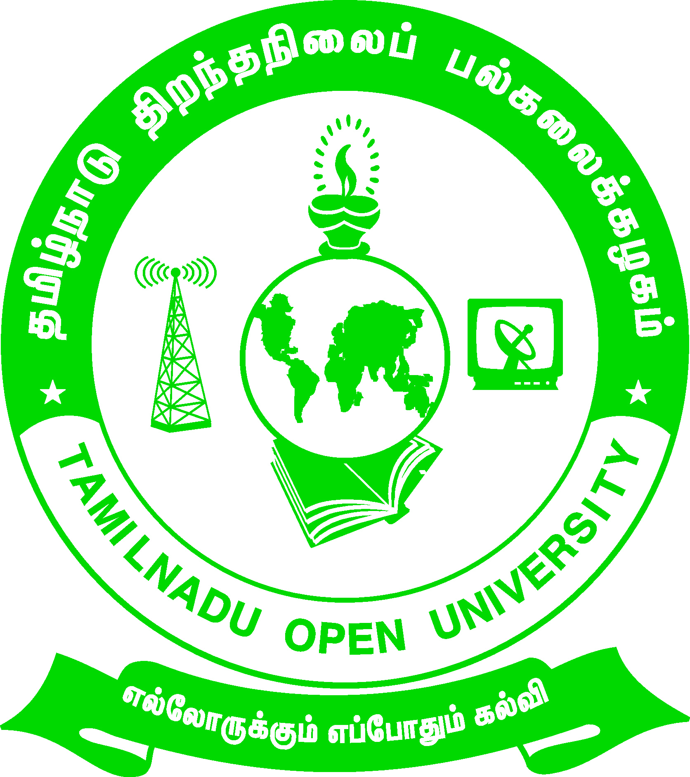 | Tamil Nadu Open University  School of Continuing Education  Chennai – 15
Name of the Programme– Vocational Diploma in Beautician - Syllabus (Flexible Skill Training Mode)
Course Title | : | Skin Care and Grooming
Course Code | : | VDIB-1
Course Credit | : | 4
Course Objectives
While studying the Skin Care and Grooming, the student shall be able to:
- Understand the anatomy and the basic skin types of the Human
- Describe the equipment and tools used for Skin Care
- Explain the steps of giving massage during facial
- Demonstrate the manicure and pedicure procedures
Course Outcomes
After completion of the Skin Care and Grooming, the student will be able to:
- State the types of skin of human
- Select the type of make-up accessories for various types of skin and situation
- Perform eye and lip make-up including corrections
- Demonstrate various types of Facials and massaging manipulations
Block- 1: Human Body Anatomy and Structure of Skin
Unit-1: Anatomy and Physiology of Human Body
Systems of the Body-Bones of the Head and Neck -Muscles of the Head and Neck -Blood Vessels of the Head and Neck -Nerves of the Head, Face and Neck- Sanitation- Bacteria- Fungi- Viruses- Professional Hygiene
Unit-2: Skin and its Structure
Structure of the Skin-Sweat Glands and the Oil Glands - Hair Follicle and Erector Pili-Skin Types-Cosmetology- Making a Professional Judgment- Healthy and Beautiful Skin - Environment and Skin Beauty -Biological Influences on the Skin -Anatomy of Acne

Unit-3: Histology of Skin
Layers of Skin - Functions of Skin - Skin Disorders- Chemistry Needed for Aesthetician’s- Electrical Gadgets Normally Used in Beauty Centres- Herbs and Natural Products Often Used -Electrical Machines & Apparatus used for Skin Care- Steam Bath
Block -2:Make-Up and Cosmetic Materials
Unit-4: Cosmetic Materials
Basic Beauty Wardrobe- Makeup and its contents- Colouring Agents- Effect of Artificial Lighting on Makeup- Implements and Materials Used- Corrective Makeup- Stage TV and Film Makeup- Difference between Stage, Film and TV Makeup- Factors to be considered while doing TV and Film Makeup- Makeup Kit
Unit-5: Eye Make-up and Hair Removal
The Structure of the Eye-Eye Treatments-Special Eye Exercises-Eye Brow Shaping- Superfluous Hair- Methods for Removal- Methods used on different Parts of the Body
Block- 3: Pedicure, Manicure and Electrotherapy
Unit-6: Manicure and Pedicure
Manicurist- Nails- Manicure- Special Manicure- Type of Services- Pedicure- Common Foot Problems- Pedicuring- Equipments Required- Procedure- Precautions
Unit-7: Electrotherapy
High Frequency- Hood Drier- Galvanic Current- Ozone Unit- Ringlets- Hot Rollers-Roller Setting- Ear and Nose Piercing
Block -4: Massage and Facials
Unit-8: Introduction to Massage
Massage - Types of Massage - General Effects of Massage - Draping for a Facial- Facial Massage - Commonly used Manipulations- Cleansing of the Skin - Steaming of the Face- Methods of Steaming
Unit-9: Massage Therapy and Facials
Types of Massage Movements- Swedish Massage- Aroma Therapy Massage-Facial- Advantage of Facial- Facial Massage Stroke- Facial Treatment

Tamil Nadu Open University
School of Continuing Education
Chennai – 15
Name of the Programme– Vocational Diploma in Beautician - Syllabus (Flexible Skill Training Mode)
Course Title | : | Hair Care and Styling
Course Code | : | VDIB-2
Course Credit | : | 4
Course Objectives

While studying the Hair Care and Styling, the student shall be able to:
- Learn about the structure and types of Hair
- Describe about scalp manipulation and hair rinsing process
- Explain the procedure for various thermal hair styling like roll, straightening preming
- Gain knowledge about hair colouring and the process
Course Outcomes
After completion of the Course Hair Care and Styling, the student will be able to:
- Explain the hair growth rate and hair damages
- Demonstrate the hair shampooing techniques
- Handle various types of hair colouring and dyeing materials and perform the hair colouring
- Perform different types of hair cut like bob, straight cut etc.
Block -1: Hair and Hair Rinsing
Unit-1: Study of Hair
Introduction-Structure of the Hair-Growth Rate of Hair-Types of Hair-Characteristics of the hair shaft-Biological Effects upon Hair-Diseases and disorders of the Hair and Scalp- Practices that Damage Hair-Analyse Hair and Scalp-Scalp Manipulations
Unit-2: Hair Rinsing
Shampooing-Different Types of Shampoos-The Choice of a Shampoo-Shampooing Clients Hair

Block -2: Hair Styling and Colouring
Unit-3: Thermal Hair Styling
Methods of Hair Designing-Thermal Air Styling – Blow Drying-Hot Rollers-Curly Hair Style-Curling Irons-Thermal Relaxing Techniques-Straightening-Hair Perming
Unit-4: Hair Colouring
Hair Colouring-Basic Principles of Colour-Classification of the Hair Colour-Hair Colour Record-Henna treatment-Herbal Hair Dye-Fancy Hair Colouring-Highlighting-Lighteners and Their Effects-Toners (Two-step tints)
Block- 3:Hair Treatments and Bob Cut
Unit-5: Hair Treatment
Hair Treatment-Scalp Treatment-Hot Oil Massage-Henna Conditioning-Protein Conditioning-Split Ends Remedy
Unit-6: Hair Cut – Bob
Step By Step Procedure-The Finish Procedure-Finished Look
Block- 4:Other Types Of Hair Cuts
Unit-7: Forward Graduation Cut
Step by Step Procedures-The Cut-The Finish-Finish Look
Unit-8: One Length Cut
Step by Step Procedures-The Cut-The Finish-The Finished Look

Tamil Nadu Open University
School of Continuing Education
Chennai – 15
Name of the Programme– Vocational Diploma in Beautician- Syllabus (Flexible Skill Training Mode)
Course Title | : | Entrepreneurship Development
Course Code | : | VDIB-3
Course Credit | : | 4
Course Objectives

While studying the Entrepreneurship Development, the student shall be able to:
- Explain about Entrepreneurs and characteristics of them
- Describe the Parlour maintenance and client handling
- Explain the creation and submission of Project Proposal
- Aware of institutional support and financial avenues available for entrepreneurs
Course Outcomes
After completion of the Course Entrepreneurship Development, the student will be able to:
- Plan about the setting of a saloon/ parlour
- Devise a Project Proposal for want of fund/ loan
- List the ways of handling the customer and hygiene management of parlour
Block-1: Entrepreneurship and Beauty Profession
Unit-1 – Entrepreneurship
Definition and Meaning of Entrepreneur- Characteristics of Entrepreneur - Functions of Entrepreneur- Classification of Entrepreneurs-Role and Importance of Entrepreneurship- Evolution of Indian Entrepreneurship- Women Entrepreneurs
Unit-2: Beauty Profession – Ethics and Qualities
Beauty Profession- Professional Ethics in Salon- Client/Customer Relationship in Beauty Parlour- Physical presentation of beauty salon professional-Qualities of Beauty professional- Opportunities and Progression in Beauty Profession
Block- 2: Saloon Planning and Management
Unit-3: Client Consultation and Understanding
Client consultation- Consultation Steps and Techniques- Client consultation Tool- Understand Your Client Types
Unit-4: Beauty Salon Planning and Management
Beauty Salon - Beauty Salon Business Planning- Managing Steps for Beauty Salon-Planning for beauty salon lay out - Selection of tools and equipment- Recommendation for Professional Beauty Products
Block -3: Creation of Project and Starting a Small Scale Enterprise
Unit-5: Project Identification
Meaning of Project- Characteristics of a Project- Classification of a Project- Project Objectives- Project Selection- Stages in the process of Project or Project Life Cycle- Project Appraisal- Financial Criteria- Project Report - Characteristics of a Successful Business Plan- Financial Analysis- Cash Flow Analysis- Budgets and Budgetary Control
Unit-6: Steps for Starting a Small Scale Enterprise
Introduction to Small Scale Industries- Setting-up a Small-Scale Unit - Problems related to Small-Scale Industries- Measures for improvement- Government policies and measures to improve Small-Scale Industries- List of items reserved for Small-Scale Industries - Role of Small-Scale Industries in the Indian Economy - Incentives and Subsidies offered to Small Scale Industries- Subsidies and Incentives in Tamilnadu- Small Industries Development Bank of India- Sole trader / Sole proprietorship- Partnership- Joint Stock Company
Block -4: Institutional Finance and Support to Entrepreneurs
Unit-7: Institutional Finance and Entrepreneurs
Introduction to Entrepreneurial Development Programme (EDP) - Role of Government and Non-Government, National, State and District level Institutions to assist EDPs- Financial Institutions- Other Financial Intuitions-Jawahar Rozgar Yojana Scheme (JRY)
Unit-8: Institutional Support to Entrepreneurs
Role of Government and Non-Government institutions-National Small Industries Corporation (NSIC)-Small Industries Development Organization (SIDO) - District Industries Centres(DIC)-Technical Consultancy Organizations(TCO)- The Tamil Nadu Industrial Investment Corporation Ltd(TIIC)- Khadi and Village Industries Commission(KVIC)- Industrial Estates-Industrial and Technical Consultancy Organization Of Tamil Nadu(ITCOT)-State Industrial Promotion Corporation of Tamil Nadu Limited (SIPCOT)-Total Quality Management (TQM)-International Standards Organization (ISO)- Other institute support to the entrepreneur- Small Scale Industries Policy-Rural Entrepreneurship

Tamil Nadu Open University
School of Continuing Education
Chennai – 15
Name of the Programme– Vocational Diploma in Beautician- Syllabus (Flexible Skill Training Mode)
Course Title | : | Skin Care (Practical)
Course Code | : | VDIB- P1
Course Credit | : | 4
- Handling of equipments used for skin care
- Skin testing
- Mini facial
- Herbal facial
- Galvanic facial
- Aroma facial
- Biotech facial
- Pearl facial
- Fruit facial
- Vegetable facial
- Eye brow trimming
- Pimple treatment
- Bleaching
- Powder bleach
- Detanning
- Pedicure
- Manicure

Tamil Nadu Open University
School of Continuing Education
Chennai – 15
Name of the Programme– Vocational Diploma in Beautician- Syllabus (Flexible Skill Training Mode)
Course Title | : | Hair care, Make-up and Mehandi
Course Code | : | VDIB- P1
Course Credit | : | 4

- Handling of hair care equipments
- Hot oil massage
- Henna Hair conditioning
- Dandruff treatment
- Hair dyeing
- Coloring
- Straightening
- Different Styles of Haircuts - 5
- Types of hair styles – 5
- Art of Mehandhi
- Party makeup
- Bridal Makeup

Tamil Nadu Open University
School of Continuing Education
Chennai – 15
Life Coping Skills (LCS) and Communication Skills (CNS)-Core Course for all Vocational Diploma Programmes
Life Coping Skills and Communication Skills have been included to help the students to understand the meaning of life and to understand the meaning of relationship and how we communicate in every day life.
Examination System: Examination to Life Coping Skills and Communication Skills are designed to maintain quality of standard. Theory will be conducted by the University in the identified Examination Centres. For the Spot Assignment students may be permitted to write with the help of books/materials for each Course, which will be evaluated by the Evaluators appointed by the University.
Assignment (Internal): Assignment carries 30 marks, consists of descriptive type of questions for each Course (3 X 10 = 30 Marks). Learners are expected to write 10-15 pages for each assignment. Submission of Assignment is compulsory.
Theory Examination (External): Students shall normally be allowed to appear for Theory Examination by completing Practical and Assignment. The Term-End Examination shall carry Section- A, Section- B and Section- C
Section-A | Three out of Five Short Answer Questions [Each 3- Marks] | 3 X 3 = 9 Marks
Section-B | Three out of Five Long Answer Questions [Each 7- Marks] | 3 X 7 = 21 Marks
Section-C | Four out of Seven Essay questions of which one will be Multiple Choice Question  [Each 10-marks] | 4 X 10 = 40 Marks
Total |  | 70 Marks
Passing Minimum: The passing minimum is 35 percent in the internal and external/ theory examination taken together for successful completion of each course.

Tamil Nadu Open University
School of Continuing Education
Chennai – 15
Name of the Course – Life Coping Skills - Syllabus (Flexible Skill Training Mode)
Course Title | : | Life Coping Skills
Course Code | : | LCS
Course Credit | : | 6
(1).Life Coping Skills : The main objectives of the Life Coping skills is to understand the meaning of life and its challenges, provide skills and knowledge needed to cope with life’s problems and challenges, develop a positive attitude, train to be successful and useful citizens through positive thinking, cope with criticism, failure, anger, loneliness, physical and verbal abuse, improve self-esteem, manage time and stress, develop one’s personality to its full potential, help the students to become team players, develop personal skills and to provide skill problems solving and decision making.
Block- 1-Self Skills
Unit-1: Self Skill – I
Meaning and Process of Coping- Restructuring the Life Story - External and Internal Influences in One's Life - Messages: Positive and Negative - Life Illustrations - Self Esteem - Self Concept - Self Acceptance - Self Actualisation- Personality Development
Unit-2: Self Skill – II
Positive Thinking - Goal Setting - Problem Solving - Decision Making
Block- 2: Social and Leadership Skills
Unit-3: Social Skills
Social Skills- Motivation- De-motivating Factor- Meaning and Attitude to Success- Time Management -The Management of Time is the Management of Life - How to gain an extra mile every day- Tips for Time Management - Stress Management
Unit-4: Leadership Skills
Emergence of a Leader -Characteristics of Leadership -Various kinds of Leaders -What should Leader do- The Moulding of a Leader - Characteristics of a Successful Leader- Team Work - What is it like work in a Team- What is Team Learning
Unit-5: Coping Skills – I
What is Shyness- How to Overcome Shyness- Tips to Overcome Shyness - Coping with Loneliness-Finding Ways to Change the Feelings of Loneliness-Overcoming Loneliness - Tips to Overcome Loneliness- Coping with Depression - Coping with Fear- Coping with Anger and Verbal Abuse -Verbal Abuse- Coping with Failure - Coping with Criticism
Unit-6: Coping Skills – II
Coping with HIV – AIDS- Coping with Alcoholism - Tobacco and Smoking - Coping with Substance Abuse
Block -4: Managerial and Entrepreneur Skills
Unit-7: Managerial Skills
Coping with Conflict- Conflict can be Constructive or Destructive- Constructive Nature of Conflicts- What are the Strategies for Managing Conflicts- Tactics of Conflict Management- Coping with Change- Twelve Steps to Implement Change
Unit-8: Entrepreneur Skills
Career Guidance - Career Planning- Preparation for Employment- Looking for Opportunities - Preparation for the Interview - Work Environment - Thriving in Today's Work Environment .

Tamil Nadu Open University
School of Continuing Education
Chennai – 15
Name of the Course – Communication Skills - Syllabus (Flexible Skill Training Mode)
Course Title | : | Communication Skills
Course Code | : | CNS
Course Credit | : | 6
(2).Communication Skills: The main objectives of the Communication Skills is to introduce to the students the process and kinds of communication, train the students to code and decode communication effectively, explain the various interpersonal skills required to interact with others and make the students understand the meaning of relationship and how we communicate in every day life.
Block -1: Communication
Unit-1: Introduction to Communication
Communication concept- Process of Communication- Elements of Communication- Types of Messages- Types of Communication- Speech- Different Types of Verbal Communication-Effective Communication-Interpersonal Communication- Communication as Skilled Behaviour-Social Skills Model- Social Skills Model to Interpersonal Communication-Implications of the Approach-Components of Interpersonal Skills-Characteristics of a Good Conversation-Hints for Inter-Personal Relation-Ship
Unit-2: Effective Communication
Definition of Effective Communication- Common Forms of Communication- The Positive Value of Good Communication- Guidelines for Effective Communication- Review Questions- Three Principles of Communication- Communication Strategies
Block- 2:Situational and Behavioural Communication
Unit-3: Situational Language
Greeting and Introducing- Inviting Someone and Making Requests- Offering Help and Seeking Permission- Asking for Advice and Expressing Gratitude-Asking whether Someone Remembers- Persuading, Complimenting and Congratulating- Expressing Sympathy- Complaining and Apologising- Making Suggestions and Warning Someone- Asking for Excuse and Ending a Conversation- Asking for Information and Someone's Opinion- Asking if someone is sure and to Say Something Again- Checking that you have understood- Asking whether someone knows- Asking About Possibility and Preference- Requesting Someone- Asking if someone Agrees- Asking if someone is Obliged to do something- Some Useful Expressions- Different Models of Situational Conversations
Unit-4: Behavioural Communication
Effective Criticism Made Easy: Basic Rules for Delivering-Negative Feedback to Others- Before Delivering to Negative Feedback- While Delivering Negative Feedback- After Delivering Negative Feedback
Block -3: Types and Modes of Communication
Unit-5: Modes of Communication
Group Discussion- Importance of Group Testing- Factors that Contribute to Group-Worthiness- Guidelines for Group Discussion- Factors that Matter in a Group Discussion- Important Parameters in Group Discussion- Types of Groups- Speech- Speech Distractions- Five ways to make your Audience Sit Up- Successful Public Speaking- Drafting a Speech- Major Pitfalls in Public Speaking- Body Language- The Constituents of Body Language
Unit-6: Leadership and Team Communication
Definition of a Leadership- Types of Leadership- Shared Leadership- Ten Principles for Leadership Communication- Styles of Leadership- Team Communication- Achieving Effectiveness through Team Communication- The Components of Communication- Characteristics of Highly Cohesive Teams
Block- 4:Interview Skills and English Language
Unit-7: Interview Skills
Interview Defined- Kinds of Interviews- Preparation for a Job Interview- Telephonic Interview- Preparation for a Telephonic Interview- Speaking to Foreigners- Success in Interview-Ten Most Frequently Asked Questions- Inter Whew- Inter Phew
Unit-8: English as Spoken and Written Language
Simple Sentence- Word Order- Modals- Passive Voice- Letter Writing-An Informal Letter-Formal Letter-Personal Letters- Official Letters- Paragraph Writing- Essay Writing- Types of Essay- Prose Comprehension- Poetry Comprehension- Precise Writing- Dialogues.

