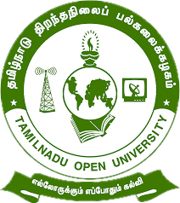

Tamil Nadu Open University
School of Continuing Education

jkpo;ehL jpwe;jepiyg; gy;fiyf;fofk;
njhlh; fy;tpf;fhdg; gs;;sp

Programme Project Report (PPR)

Vocational Diploma in Animation (VDIA)

Members of the Board of Studies [BOS]
of School of Continuing Education

S.No. | Name | Designation
1 | Dr. P. Thiyagarajan | Professor & Director  School of Continuing Education  Tamil Nadu Open University,  Chennai
2 | Dr. K. Devan | Professor & Centre Head  Centre for Adult and Continuing Education,  Pondicherry University,  R.V. Nagar, Puducherry
3 | Dr. V.P. Matheswaran | Professor & Head  Department of Adult & Continuing Education,  University of Madras,  Chepauk, Chennai
4 | Dr. S. Jayalakshmi | Assistant Professor  DDU-KAUSHAL Kendra,  Bharathidasan University,  Tiruchirappalli
5 | Mr.S.Vendan | Managing Director  Vendan Visual Effects,  Thirvanmiyur, Chennai
6 | Ms.C.Rohini Chandrasekaran | Consultant  Fair Labour Associations,  Tirupur, Tamil Nadu
7 | Mr. R. Thiyagarajan | Junior Instructor  IIDA Community College,  No.38,Bharathi Nagar Main Road,  Zamin Pallavaram, Chennai
8 | Mrs. V. Rubini | Nurse, Health Centre  Tamil Nadu Open University, Chennai
9 | Er. R. Meenambigai | Assistant Professor  School of Continuing Education  Tamil Nadu Open University,  Chennai
10 | Dr. I. Ambeth | Assistant Professor & Regional Director i/c  Madurai Regional Centre,  Tamil Nadu Open University,  Madurai

Tamil Nadu Open University
School of Continuing Education
Vocational Diploma in Animation (VDIA)
Programme Project Report (PPR)
(a). Programme’s Mission & Objectives: The main Objectives of the Vocational Diploma in Animation Programme is to train the learners for the job of an animator, designer, graphics designer, computer animator, 3D modelling animator and also building the key competencies amongst the learner.
(b).Relevance of the Programme with HEI’s Mission and Goals: Tamil Nadu Open University one of Mission and Goal is to encourage Skill Development to empower the human resource through Participatory Education System and accordingly the Vocational Diploma Programme has been developed. The Programme is being offered under flexible skill training mode.
(c). Nature of prospective target group of learners: Candidates who wish to seek employment in the Animation and Graphics industry or become an entrepreneur particularly the young boys/ girls, slum dwellers, unskilled workers employed in the mechanic field, rural dwellers, unemployed youths and minorities.
(d). Appropriateness of programme to be conducted in Open and Distance Learning mode to acquire specific skills and Competence: Apart from ODL Mode, the Programme also has been designed to offer under Flexible Skill Training mode. Animation persons are to work on the accounts of a company, maintain the office automation. To acquire Specific Skill, the Core Skills, Generic Skills and Professional Skills component are also included.
(e). Instructional Design: The Curriculum and the Syllabi are designed by covering all the aspect of Animation and Graphics Design. The duration of the Programme is One Year and it will be offered in English Medium. Required Faculties working in the Community Colleges will handle classes for the Vocational Diploma Programme in Animation. The Programme will be delivered through Community Colleges of Tamil Nadu Open University which is having required faculties and support staff. The Credit System suggested by Distance Education Bureau i.e., 32 Credits for One Year Diploma has been assigned. Print, Audio and Video materials also will be developed for the Programme.
(f).Procedure for Admissions, Curriculum Transaction and Evaluation: The admission for the Animation Programme will be carried out through on-line by Tamil Nadu Open University and the Counselling and Practical classes will be conducted through Constituent Community College and Community Colleges of Tamil Nadu Open University. The hands on training will be provided in the Industries and mobile Lab. The evaluation will be carried by Tamil Nadu Open University consists of Continuous Internal Assessment through Spot Assignment and External Assessment through Term End Examination.
(i).Eligibility: Candidates who have passed in the 10th Standard Examinations or its equivalent as per Tamil Nadu Government Order No-163 dated 22-05-2008.
(ii).Fee Structure: Rs.4,200/- (plus Registration Charges)
(g) Requirement of the laboratory support and Library Resources: Lab Facilities are made available in Constituent Community Colleges and Community Colleges of Tamil Nadu Open University as per requirement as given in the National Skill Development Corporation(NSDC), Qualification Pack(QP). Practical Manual developed by the Tamil Nadu Open University will be supplied to the Students apart from Self Learning Materials. Library Books are available at the Headquarters, Regional Centres and Constituent Community Colleges and Community Colleges of Tamil Nadu Open University.
(h). Quality Assurance Mechanism and Expected Programme Outcomes: Tamil Nadu Open University through its Centre for Internal Quality Assurance (CIQA) will monitor the delivering aspect of Constituent Community Colleges and community Colleges of TNOU for maintaining quality. Feedback will be collected from the Learners and success story if any will also be shared with learners. After completion of Animation Programme, Learner will acquire the Core Skills, Generic Skills and Professional Skills components and will be employed in the automobile Industry.
Proposed Programme Structure of Vocational Diploma in Animation
S.No | Course Code | Course Title | Credits | Marks Distribution
 |  |  |  | Internal | External | Total
1 | VDIA-1 | Digital Art and Design | 4 | 30 | 70 | 100
2 | VDIA -2 | 2D & 3D Animation | 4 | 30 | 70 | 100
3 | VDIA -3 | Visual Effects and Editing | 4 | 30 | 70 | 100
4 | VDIA-P1 | Animation (Practical) | 4 | 30 | 70 | 100
5 | VDIA -P2 | Visual Effects and Editing (Practical) | 4 | 30 | 70 | 100
6 | LCS | Life Coping Skills | 6 | 30 | 70 | 100
7 | CNS | Communication Skills | 6 | 30 | 70 | 100
Total |  |  | 32 | 210 | 490 | 700
Age: 15 years and above
Duration of Programme: 1 year and maximum of 3 years
Credits: Credits in Open and Distance Learning (ODL) is nothing but study hours. The following are explanation for Credit in ODL System.
- One Credit would mean equivalent of 30 hours of study.
- Learners are expected to allot 24 hours for reading the Self Learning Materials supplied by the University, 3 hours for viewing the video and listening the audio and 3 hours for writing assignments to complete one credit in ODL.
Examination System: Examination to Vocational Diploma Programme in Animation is designed to maintain quality of standard. Theory will be conducted by the University in the identified Examination Centres. For the Spot Assignment students may be permitted to write with the help of books/materials for each Course, which will be evaluated by the Evaluators appointed by the University.
Assignment (Internal): Assignment carries 30marks, consists of descriptive type of questions for each Course (3 X 10 = 30 Marks). Learners are expected to write 10-15 pages for each assignment. Submission of Assignment is compulsory.
Theory Examination (External): Students shall normally be allowed to appear for Theory Examination by completing Practical and Assignment. The Term-End Examination shall carry Section- A, Section- B and Section- C
Section-A | Three out of Five Short Answer Questions [Each 3- Marks] | 3 X 3 = 9 Marks
Section-B | Three out of Five Long Answer Questions [Each 7- Marks] | 3 X 7 = 21 Marks
Section-C | Four out of Seven Essay questions of which one will be Multiple Choice Question  [Each 10-marks] | 4 X 10 = 40 Marks
Total |  | 70 Marks
Passing Minimum: The passing minimum is 35 percent in the internal and external/ theory examination and overall 40 per cent for successful completion of each course.
Classification of Successful Candidate: Candidates who pass all the Courses and who secure 60 per cent and above in the aggregate of marks will be placed in the First Class. Those securing 50 per cent and above but below 60 per cent in the aggregate will be placed in the Second Class. Those securing 40 per cent and above but below 50 per cent in the aggregate will be placed in the Third Class.

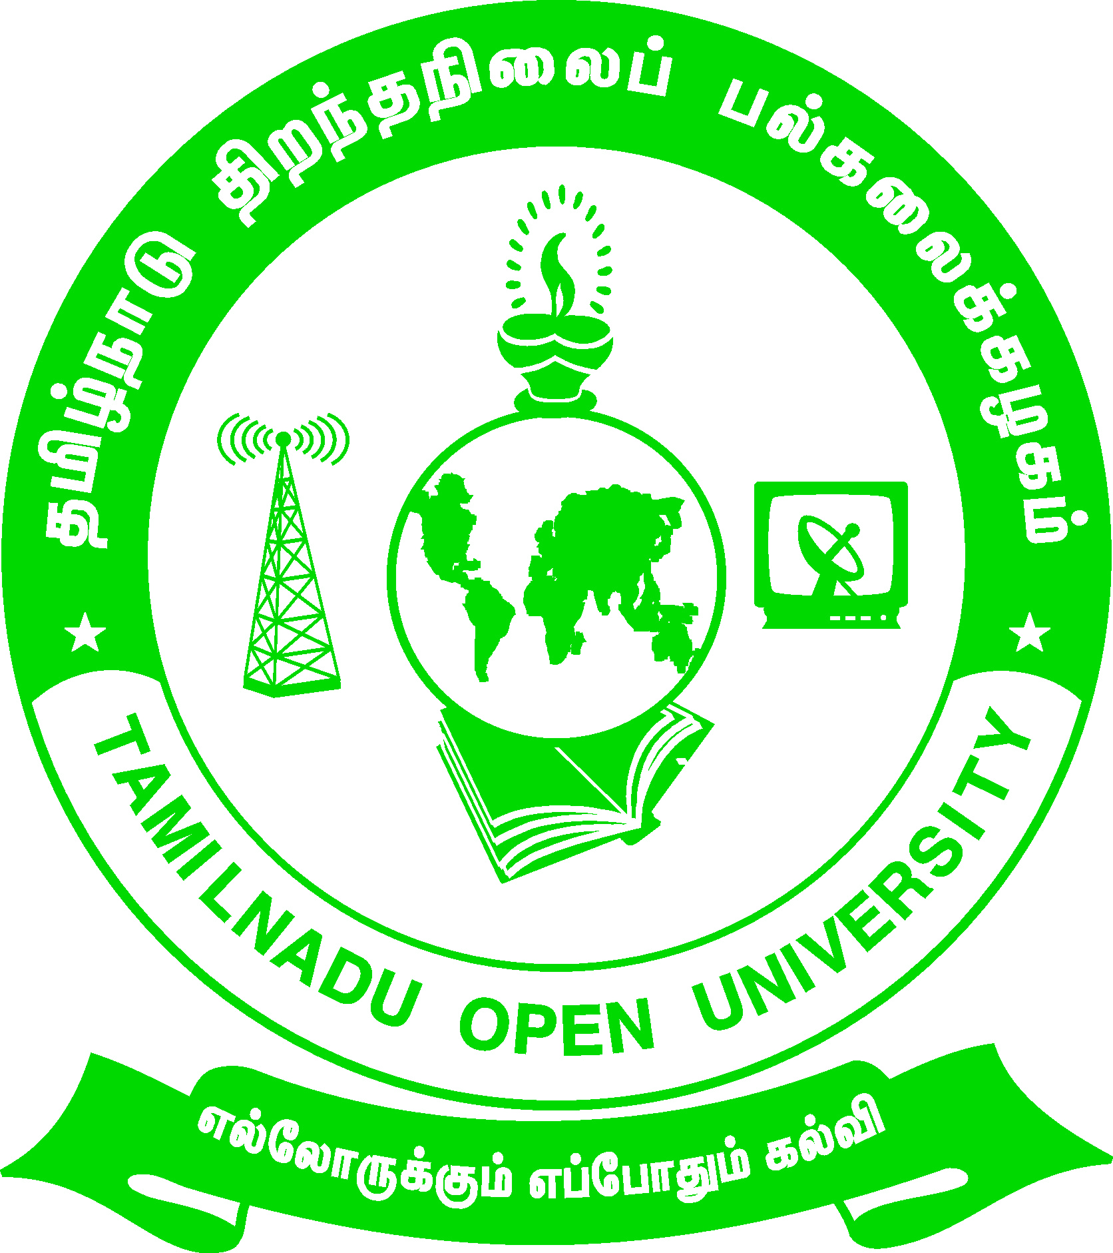 | Tamil Nadu Open University  School of Continuing Education  Chennai – 15
Name of the Programme– Vocational Diploma in Animation - Syllabus (Flexible Skill Training Mode)
Course Title | : | Digital Art and Design
Course Code | : | VDIA-1
Course Credit | : | 4
Course Objectives

While studying the Adobe Photoshop, the student shall be able to:
- Explain about the Photoshop and making basic edits
- Describe the Using layers, masks and paths
- Visualize and know about the Fine tuning your image
- Using more advanced techniques and images for the web
Course Outcomes
After completion of the Course Adobe Photoshop, the student will be able to:
- Describe the Photoshop
- State the Working with layers
- Demonstrate various techniques and images for the web
- Understand Working with image size and orientation
Block- 1: Basics of Photoshop
Unit -1: Photoshop and making basic edits
Touring the work area- Working with image files- Adding content with tools- Working with the image view- Selecting image content- Change a selection- Using positioning tools and presets.
Unit -2: Using layers, masks and paths
Working with layers-Creating a layer-Creating patterns-Deleting a layer-Setting a layer properties-Choosing a layer style-Arranging layer order-Grouping and ungrouping layers-Flattening the image
Block -2: Layer Mask and Path
Unit-3: Adding variety with masks
Adding masks-Changing quick mask options-Using quick mask to adjust a selection-Using layer mask-Putting a mask to work
Unit-4: Using Paths
Creating paths- Using clipping paths
Block- 3: Fine Tuning Images
Unit-5: Fine tuning your image
Using other Editing tools-Blurring an area-Smudging an area-Sharpening an area-Erasing image content-Adding a gradient-Filling with the paint bucket-Using photo techniques
Unit-6:Working with image size and orientation
Crapping the image-Changing the image size-Changing the canvas size-Rotating and trimming the canvas- Using a filter and printing your image.
Block -4: Advanced Techniques and Images for the Web
Unit-7: Using more advanced techniques
Understanding colours and channels- Correcting image colour -Having fun with colour- Working with plug-ins-Working with actions
Unit-8- Images for the web
Creating web images-Adding hotspots
Block-5: Illustrator
Unit-9: Vector Graphics
Drawing- Design a Logo- Gorgeous typography
Unit-10: Illustration
Create and Edit a pattern- Create and edit artwork-Combine shapes

Tamil Nadu Open University
School of Continuing Education
Chennai – 15
Name of the Programme– Vocational Diploma in Animation - Syllabus (Flexible Skill Training Mode)
Course Title | : | 2D & 3D Animation
Course Code | : | VDIA-2
Course Credit | : | 4
Course Objectives

While studying the Macromedia Flash 8, the student shall be able to:
- Explain about the Architecting a Flash Application
- Describe about Working with Graphics and Importing XML Data
- Visualize and know about the Animation with Action Script and Styling and Skinning Components
Course Outcomes
After completion of the Course Macromedia Flash 8, the student will be able to:
- Describe the origin of modern cookery
- State the aims and objectives of cooking food
- Demonstrate various ingredient preparation methods
- Understand the hierarchy of chefs and other in the kitchen
Block-1: Animate Application
Unit-1: Architecting a Animate Application
Architecting with layers-Architecting with Movie Clips-Placing code in external Action Script files-Introducing object oriented programming concepts
Unit-2: Working with Animate classes
Writing methods, functions and event handlers -Referencing dynamic variables using bracket notation-Extending the Movie Clip class-Detecting Movie Clip interactions with hit Test().
Block-2: Graphics and XML
Unit -3: Working with Graphics and Importing XML Data
Learning about Flash drawing models-Using filters -Using blends-Creating filters and blends with Action Script -Introducing bitmap caching.
Unit-4: Importing XML Data
Learning about XML -Using XML in Flash-Accessing XML data-Looping through XML data
Block-3: Text and Graphic Loading
Unit -5: Working with Text
Introducing the Text Format class-Formatting text with cascading style sheets-Resizing text fields- Creating reusable instance-based code- Loading external media with Movie Clip Loader- Creating instances of the Flash Object class
Unit-6- Implementing Advanced Graphic Loading
Implementing advanced anti-alias rendering - Introducing listeners and event handlers Understanding the Movie Clip Loader event handlers- Using create Empty Movie Clip() and get Next Highest Depth()- Attaching Movie Clips - Positioning visual elements dynamically- Understanding swapping depths .
Block-4: Animation with Action Script
Unit-7: Animation with Action Script and Styling
Creating Timeline based custom easing- Animating with Action Script-Interacting with the mouse location- Adding easing via Action Script- Creating a mask with Action Script .
Unit-8: Tween class and Transition classes and Skinning Components
Introducing the Tween class Handling-Tween class events- Introducing the Transition classes- Styling components- Skinning components with themes -Skinning components manually
Block-5: 3D Animation using Maya
Unit-9: 3D Animation
Create expansive worlds-Complex characters -Rigging -Performance capture -Animation
Unit-10: Motion Graphics and VFX Effects
Rendering and shading- Dynamics and effects -Deep adaptive liquid simulation-Interactive hair grooming

Tamil Nadu Open University
School of Continuing Education
Chennai – 15
Name of the Programme– Vocational Diploma in Animation - Syllabus (Flexible Skill Training Mode)
Course Title | : | Visual Effects and Editing
Course Code | : | VDIA-3
Course Credit | : | 4
Course Objectives

While studying the Visual Effects and Editing, the student shall be able to:
- Explain about the Importing, Capturing Project Elements and Working with clips
- Describe the Editing Techniques, Transitions and Titles Effects and working with audio
- Visualize and know about the Export Settings and Options, Curve Creation and Polygon Modeling Techniques
Course Outcomes
After completion of the Course Video Editing, Computer Graphics and Modeling, the student will be able to:
- Describe the Video Capture Tips and Options
- State about Storyboard Editing
- Demonstrate various Transitions and Titles Effects
- Understand the Motion Paths
Block-1: Visual Effects
Unit- 1: Animation using After Effects
Create cinematic movie titles, intros, and transitions-Animate a logo or character-Build custom transitions-Remove an object from a clip and add in stunning visuals
Unit-2: Building Transitions and Clipping
Introduction to Transitions - Understanding Transitions and Applying Transitions Automatically -Applying Transitions Manually -Adjusting Transitions –Previewing- Transitions and Customizing Transitions-Creating and Opening Title Files-Title Backgrounds and Video Safe Zones -Creating Title Text- Curved Text- Creating Shape Objects and Modifying Shape Objects-Custom Styles -Rolling and Crawling Text
Block-2: Creative Composting using After Effects
Unit -3: Working with Layers and Audio Mixing
Importing Layered Files & Adding Easing - Working with Numerous Layers - Vector Layouts & the Graph Editor - Putting It All Together & Adding Audio - Hard Ease Fashion Reveal - Setting Keyframe Velocity for fine-tuned ease control - Understanding basic motion paths - Sequencing the “stripes” - Adding a Drop Shadow effect - Time Remapping to Match Audio
Unit-4: Lighting and Rendering
3D Lighting & the Wiggler - More 3D Fun: Lights, Rotation, Motion - Using 3D Cameras - Rendering & Exporting Options - Background Lighting & Cropping Square Videos - Constructing a Seamless 3D Object - Animating a 3D Object - Lighting & shadows on 3D objects - Adding music & adjusting keyframe timing - Adding a lens flare effect to a solid & animating it.
Block-3: Editing
Unit -5: Editing Video using Premiere Pro
Getting Started- Importing Video and audio files- The Media Browser and P2 files- Synchronising audio and video with Merge Clips - A note about Conforming - Using the Storyboard feature in the Project panel – Metadata - Creating new sequences automatically - Moving clips to the Timeline - Moving, trimming and deleting clips on the Timeline - Markers and Subclips - Using the Source monitor; editing clips with In and Out points - Inserting and overwriting edits - Working with Linked Selection
Unit -6: Adding effects and transitions
The Toolbar - Ripple and Rolling edits, creating J and L cuts - Slip and Slide edits - Lift and Extract - Adding Transitions - Adding Effects and Keyframes - Applying Keyframes to the Timeline - Basic time changes - Colour Grading - Compositing with Ultra Key - Rendering and previews
Block-4: Crafting Videos
Unit -7: Audio Mixing and Titling
Adjusting clip volume - Cleanup and optimisation with the new Essential Sound panel - Using the Audio Track Mixer - Offline media - Replacing clips on the Timeline - Adding titles with the new Essential Graphics panel
Unit-8: Multi Camera Editing and Exporting
Organising and selecting camera angles for Multi-Camera mode - Creating a Multi-Camera edit - Exporting single frames - Exporting audio - Exporting to web-ready video - Exporting video with the Adobe Media Encoder

Tamil Nadu Open University
School of Continuing Education
Chennai – 15
Name of the Programme– Vocational Diploma in Animation - Syllabus (Flexible Skill Training Mode)
Course Title | : | Animation Lab
Course Code | : | VDIA-P1
Course Credit | : | 4
Adobe Flash
- Flash Embedded in HTML
- How to make an object move across the screen
- How to draw a path an object should follow
- How to change the colour of an object and also to change one object into another
- Insert an image, convert it to a button, and add a URL to it so it becomes a link.
- Create your own button and add a URL to it so it becomes a link.
- Create mobile communication process to send and receive a message with action script
- Create mailbox actins with action script
Adobe Photoshop
- Create a website that looks like a desk. Complete with stained wood, note paper, and some pencils strewn around.
- Create some basic natural elements as the basis for a web page layout
- Create a scorched parchment texture, for a website or wedding invitation.
- Use Nudge and Inner Shadow to give a button that pressed-down look while the mouse cursor is over it to create a website with a very nice, sparkling, sepia effect
- Make a simple, two-colour menu for a website in Photoshop, and shows how to turn it into a web page in your web editor.
Create a graphical web page header in Adobe P
- hotoshop
- Design your own company LOGO.

Tamil Nadu Open University
School of Continuing Education
Chennai – 15
Name of the Programme– Vocational Diploma in Animation - Syllabus (Flexible Skill Training Mode)
Course Title | : | Visual Effects and Editing
Course Code | : | VDIA-P2
Course Credit | : | 4
- Hypershade and Textures in Alias Maya
- An Adventure in Photogrammetry
- Animating a flying balloon with a string
- Introduction to Maya Expressions
- Making MEL procedures
- Introduction to MEL scripting
- Maya Hair Club for Men (and Women)
- Modeling a Head with Subdivision Emulation in Maya Complete
- Create a moving Tentacle using Procedural animation
- Modeling a Head with Subdivision Emulation
- Organic Modeling and Animation in Maya
- Spotlight Fog
- The bouncing ball
- Walk with an expression (walking, running, skiing, rowing)
- Emit Geometry from a Point Emitter

Tamil Nadu Open University
School of Continuing Education
Chennai – 15
Life Coping Skills (LCS) and Communication Skills (CNS)-Core Course for all Vocational Diploma Programmes
Life Coping Skills and Communication Skills have been included to help the students to understand the meaning of life and to understand the meaning of relationship and how we communicate in every day life.
Examination System: Examination to Life Coping Skills and Communication Skills are designed to maintain quality of standard. Theory will be conducted by the University in the identified Examination Centres. For the Spot Assignment students may be permitted to write with the help of books/materials for each Course, which will be evaluated by the Evaluators appointed by the University.
Assignment (Internal): Assignment carries 30 marks, consists of descriptive type of questions for each Course (3 X 10 = 30 Marks). Learners are expected to write 10-15 pages for each assignment. Submission of Assignment is compulsory.
Theory Examination (External): Students shall normally be allowed to appear for Theory Examination by completing Practical and Assignment. The Term-End Examination shall carry Section- A, Section- B and Section- C
Section-A | Three out of Five Short Answer Questions [Each 3- Marks] | 3 X 3 = 9 Marks
Section-B | Three out of Five Long Answer Questions [Each 7- Marks] | 3 X 7 = 21 Marks
Section-C | Four out of Seven Essay questions of which one will be Multiple Choice Question  [Each 10-marks] | 4 X 10 = 40 Marks
Total |  | 70 Marks
Passing Minimum: The passing minimum is 35 percent in the internal and external/ theory examination taken together for successful completion of each course.

Tamil Nadu Open University
School of Continuing Education
Chennai – 15
Name of the Course – Life Coping Skills - Syllabus (Flexible Skill Training Mode)
Course Title | : | Life Coping Skills
Course Code | : | LCS
Course Credit | : | 6
(1).Life Coping Skills : The main objectives of the Life Coping skills is to understand the meaning of life and its challenges, provide skills and knowledge needed to cope with life’s problems and challenges, develop a positive attitude, train to be successful and useful citizens through positive thinking, cope with criticism, failure, anger, loneliness, physical and verbal abuse, improve self-esteem, manage time and stress, develop one’s personality to its full potential, help the students to become team players, develop personal skills and to provide skill problems solving and decision making.
Block- 1-Self Skills
Unit-1: Self Skill – I
Meaning and Process of Coping- Restructuring the Life Story - External and Internal Influences in One's Life - Messages: Positive and Negative - Life Illustrations - Self Esteem - Self Concept - Self Acceptance - Self Actualisation- Personality Development
Unit-2: Self Skill – II
Positive Thinking - Goal Setting - Problem Solving - Decision Making
Block- 2: Social and Leadership Skills
Unit-3: Social Skills
Social Skills- Motivation- De-motivating Factor- Meaning and Attitude to Success- Time Management -The Management of Time is the Management of Life - How to gain an extra mile every day- Tips for Time Management - Stress Management
Unit-4: Leadership Skills
Emergence of a Leader -Characteristics of Leadership -Various kinds of Leaders -What should Leader do- The Moulding of a Leader - Characteristics of a Successful Leader- Team Work - What is it like work in a Team- What is Team Learning
Unit-5: Coping Skills – I
What is Shyness- How to Overcome Shyness- Tips to Overcome Shyness - Coping with Loneliness-Finding Ways to Change the Feelings of Loneliness-Overcoming Loneliness - Tips to Overcome Loneliness- Coping with Depression - Coping with Fear- Coping with Anger and Verbal Abuse -Verbal Abuse- Coping with Failure - Coping with Criticism
Unit-6: Coping Skills – II
Coping with HIV – AIDS- Coping with Alcoholism - Tobacco and Smoking - Coping with Substance Abuse
Block -4: Managerial and Entrepreneur Skills
Unit-7: Managerial Skills
Coping with Conflict- Conflict can be Constructive or Destructive- Constructive Nature of Conflicts- What are the Strategies for Managing Conflicts- Tactics of Conflict Management- Coping with Change- Twelve Steps to Implement Change
Unit-8: Entrepreneur Skills
Career Guidance - Career Planning- Preparation for Employment- Looking for Opportunities - Preparation for the Interview - Work Environment - Thriving in Today's Work Environment .

Tamil Nadu Open University
School of Continuing Education
Chennai – 15
Name of the Course – Communication Skills - Syllabus (Flexible Skill Training Mode)
Course Title | : | Communication Skills
Course Code | : | CNS
Course Credit | : | 6
(2).Communication Skills: The main objectives of the Communication Skills is to introduce to the students the process and kinds of communication, train the students to code and decode communication effectively, explain the various interpersonal skills required to interact with others and make the students understand the meaning of relationship and how we communicate in every day life.
Block -1: Communication
Unit-1: Introduction to Communication
Communication concept- Process of Communication- Elements of Communication- Types of Messages- Types of Communication- Speech- Different Types of Verbal Communication-Effective Communication-Interpersonal Communication- Communication as Skilled Behaviour-Social Skills Model- Social Skills Model to Interpersonal Communication-Implications of the Approach-Components of Interpersonal Skills-Characteristics of a Good Conversation-Hints for Inter-Personal Relation-Ship
Unit-2: Effective Communication
Definition of Effective Communication- Common Forms of Communication- The Positive Value of Good Communication- Guidelines for Effective Communication- Review Questions- Three Principles of Communication- Communication Strategies
Block- 2:Situational and Behavioural Communication
Unit-3: Situational Language
Greeting and Introducing- Inviting Someone and Making Requests- Offering Help and Seeking Permission- Asking for Advice and Expressing Gratitude-Asking whether Someone Remembers- Persuading, Complimenting and Congratulating- Expressing Sympathy- Complaining and Apologising- Making Suggestions and Warning Someone- Asking for Excuse and Ending a Conversation- Asking for Information and Someone's Opinion- Asking if someone is sure and to Say Something Again- Checking that you have understood- Asking whether someone knows- Asking About Possibility and Preference- Requesting Someone- Asking if someone Agrees- Asking if someone is Obliged to do something- Some Useful Expressions- Different Models of Situational Conversations
Unit-4: Behavioural Communication
Effective Criticism Made Easy: Basic Rules for Delivering-Negative Feedback to Others- Before Delivering to Negative Feedback- While Delivering Negative Feedback- After Delivering Negative Feedback
Block -3: Types and Modes of Communication
Unit-5: Modes of Communication
Group Discussion- Importance of Group Testing- Factors that Contribute to Group-Worthiness- Guidelines for Group Discussion- Factors that Matter in a Group Discussion- Important Parameters in Group Discussion- Types of Groups- Speech- Speech Distractions- Five ways to make your Audience Sit Up- Successful Public Speaking- Drafting a Speech- Major Pitfalls in Public Speaking- Body Language- The Constituents of Body Language
Unit-6: Leadership and Team Communication
Definition of a Leadership- Types of Leadership- Shared Leadership- Ten Principles for Leadership Communication- Styles of Leadership- Team Communication- Achieving Effectiveness through Team Communication- The Components of Communication- Characteristics of Highly Cohesive Teams
Block- 4:Interview Skills and English Language
Unit-7: Interview Skills
Interview Defined- Kinds of Interviews- Preparation for a Job Interview- Telephonic Interview- Preparation for a Telephonic Interview- Speaking to Foreigners- Success in Interview-Ten Most Frequently Asked Questions- Inter Whew- Inter Phew
Unit-8: English as Spoken and Written Language
Simple Sentence- Word Order- Modals- Passive Voice- Letter Writing-An Informal Letter-Formal Letter-Personal Letters- Official Letters- Paragraph Writing- Essay Writing- Types of Essay- Prose Comprehension- Poetry Comprehension- Precise Writing- Dialogues.

