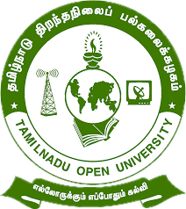

Tamil Nadu Open University
School of Continuing Education

jkpo;ehL jpwe;jepiyg; gy;fiyf;fofk;
njhlh; fy;tpf;fhdg; gs;;sp

Programme Project Report (PPR)

Vocational Diploma in Fashion Design and Garment Making (VDFG)

Members of the Board of Studies [BOS]
of School of Continuing Education

S.No. | Name | Designation
1 | Dr. P. Thiyagarajan | Professor & Director  School of Continuing Education  Tamil Nadu Open University,  Chennai
2 | Dr. K. Devan | Professor & Centre Head  Centre for Adult and Continuing Education,  Pondicherry University,  R.V. Nagar, Puducherry
3 | Dr. V.P. Matheswaran | Professor & Head  Department of Adult & Continuing Education,  University of Madras,  Chepauk, Chennai
4 | Dr. S. Jayalakshmi | Assistant Professor  DDU-KAUSHAL Kendra,  Bharathidasan University,  Tiruchirappalli
5 | Mr.S.Vendan | Managing Director  Vendan Visual Effects,  Thirvanmiyur, Chennai
6 | Ms.C.Rohini Chandrasekaran | Consultant  Fair Labour Associations,  Tirupur, Tamil Nadu
7 | Mr. R. Thiyagarajan | Junior Instructor  IIDA Community College,  No.38,Bharathi Nagar Main Road,  Zamin Pallavaram, Chennai
8 | Mrs. V. Rubini | Nurse, Health Centre  Tamil Nadu Open University, Chennai
9 | Er. R. Meenambigai | Assistant Professor  School of Continuing Education  Tamil Nadu Open University,  Chennai
10 | Dr. I. Ambeth | Assistant Professor & Regional Director i/c  Madurai Regional Centre,  Tamil Nadu Open University,  Madurai

Tamil Nadu Open University
School of Continuing Education
Vocational Diploma in Fashion Design and Garment Making (VDFG)
Programme Project Report (PPR)
(a). Programme’s Mission & Objectives: The main Objectives of the Vocational Diploma in Fashion Design and Garment Making Programme is to train the learners for the job of tailor, garment constructor, pattern creator, pattern grader, embroider and also building the key competencies amongst the learner.
(b).Relevance of the Programme with HEI’s Mission and Goals: Tamil Nadu Open University one of Mission and Goal is to encourage Skill Development to empower the human resource through Participatory Education System and accordingly the Vocational Diploma Programme has been developed. The Programme is being offered under flexible skill training mode.
(c). Nature of prospective target group of learners: Candidates who wish to seek employment in the Textile industry or become an entrepreneur particularly the young girls, slum dwellers, unskilled workers employed in the mechanic field, rural dwellers, unemployed youths and minorities.
(d). Appropriateness of programme to be conducted in Open and Distance Learning mode to acquire specific skills and Competence: Apart from ODL Mode, the Programme also has been designed to offer under Flexible Skill Training mode. Fashion Design and Garment Making persons are to design various garments for men, women and children, create and grade a pattern, create many embroidery designs. To acquire Specific Skill, the Core Skills, Generic Skills and Professional Skills component are also included.
(e). Instructional Design: The Curriculum and the Syllabi are designed by covering all the aspect of garment construction and embroidery. The duration of the Programme is One Year and it will be offered both English and Tamil Medium. Required Faculties working in the Community Colleges will handle classes for the Vocational Diploma Programme in Fashion Design and Garment Making. The Programme will be delivered through Community Colleges of Tamil Nadu Open University which is having required faculties and support staff. The Credit System suggested by Distance Education Bureau i.e., 32 Credits for One Year Diploma has been assigned. Print, Audio and Video materials also will be developed for the Programme.
(f).Procedure for Admissions, Curriculum Transaction and Evaluation: The admission for the Fashion Design and Garment Making Programme will be carried out through on-line by Tamil Nadu Open University and the Counselling and Practical classes will be conducted through Constituent Community College and Community Colleges of Tamil Nadu Open University. The hands on training will be provided in the Industries and mobile Lab. The evaluation will be carried by Tamil Nadu Open University consists of Continuous Internal Assessment through Spot Assignment and External Assessment through Term End Examination.
(i).Eligibility: Candidates who have passed in the 10th Standard Examinations or its equivalent as per Tamil Nadu Government Order No-163 dated 22-05-2008.
(ii).Fee Structure: Rs.4,200/- (plus Registration Charges)
(g) Requirement of the laboratory support and Library Resources: Lab Facilities are made available in Constituent Community Colleges and Community Colleges of Tamil Nadu Open University as per requirement as given in the National Skill Development Corporation(NSDC), Qualification Pack(QP). Practical Manual developed by the Tamil Nadu Open University will be supplied to the Students apart from Self Learning Materials. Library Books are available at the Headquarters, Regional Centres and Constituent Community Colleges and Community Colleges of Tamil Nadu Open University.
(h). Quality Assurance Mechanism and Expected Programme Outcomes: Tamil Nadu Open University through its Centre for Internal Quality Assurance (CIQA) will monitor the delivering aspect of Constituent Community Colleges and community Colleges of TNOU for maintaining quality. Feedback will be collected from the Learners and success story if any will also be shared with learners. After completion of Fashion Design and Garment Making Programme, Learner will acquire the Core Skills, Generic Skills and Professional Skills components and will be employed in the automobile Industry.
Proposed Programme Structure of Vocational Diploma in Fashion Design and Garment Making
S.No | Course Code | Course Title | Credits | Marks Distribution
 |  |  |  | Internal | External | Total
1 | VDFG-1 | Basic Garment Construction | 4 | 30 | 70 | 100
2 | VDFG-2 | Pattern Making and Grading | 4 | 30 | 70 | 100
3 | VDFG-3 | Fashion Design and Embroidery | 4 | 30 | 70 | 100
4 | VDFG-P1 | Garment Construction (Practical) | 4 | 30 | 70 | 100
5 | VDFG-P2 | Fashion Design and Embroidery (Practical) | 4 | 30 | 70 | 100
6 | LCS | Life Coping Skills | 6 | 30 | 70 | 100
7 | CNS | Communication Skills | 6 | 30 | 70 | 100
Total |  |  | 32 | 210 | 490 | 700
Age: 15 years and above
Duration of Programme: 1 year and maximum of 3 years
Credits: Credits in Open and Distance Learning (ODL) is nothing but study hours. The following are explanation for Credit in ODL System.
- One Credit would mean equivalent of 30 hours of study.
- Learners are expected to allot 24 hours for reading the Self Learning Materials supplied by the University, 3 hours for viewing the video and listening the audio and 3 hours for writing assignments to complete one credit in ODL.
Examination System: Examination to Vocational Diploma Programme in Fashion Design and Garment Making is designed to maintain quality of standard. Theory will be conducted by the University in the identified Examination Centres. For the Spot Assignment students may be permitted to write with the help of books/materials for each Course, which will be evaluated by the Evaluators appointed by the University.
Assignment (Internal): Assignment carries 30marks, consists of descriptive type of questions for each Course (3 X 10 = 30 Marks). Learners are expected to write 10-15 pages for each assignment. Submission of Assignment is compulsory.
Theory Examination (External): Students shall normally be allowed to appear for Theory Examination by completing Practical and Assignment. The Term-End Examination shall carry Section- A, Section- B and Section- C
Section-A | Three out of Five Short Answer Questions [Each 3- Marks] | 3 X 3 = 9 Marks
Section-B | Three out of Five Long Answer Questions [Each 7- Marks] | 3 X 7 = 21 Marks
Section-C | Four out of Seven Essay questions of which one will be Multiple Choice Question  [Each 10-marks] | 4 X 10 = 40 Marks
Total |  | 70 Marks
Passing Minimum: The passing minimum is 35 percent in the internal and external/ theory examination and overall 40 per cent for successful completion of each course.
Classification of Successful Candidate: Candidates who pass all the Courses and who secure 60 per cent and above in the aggregate of marks will be placed in the First Class. Those securing 50 per cent and above but below 60 per cent in the aggregate will be placed in the Second Class. Those securing 40 per cent and above but below 50 per cent in the aggregate will be placed in the Third Class.

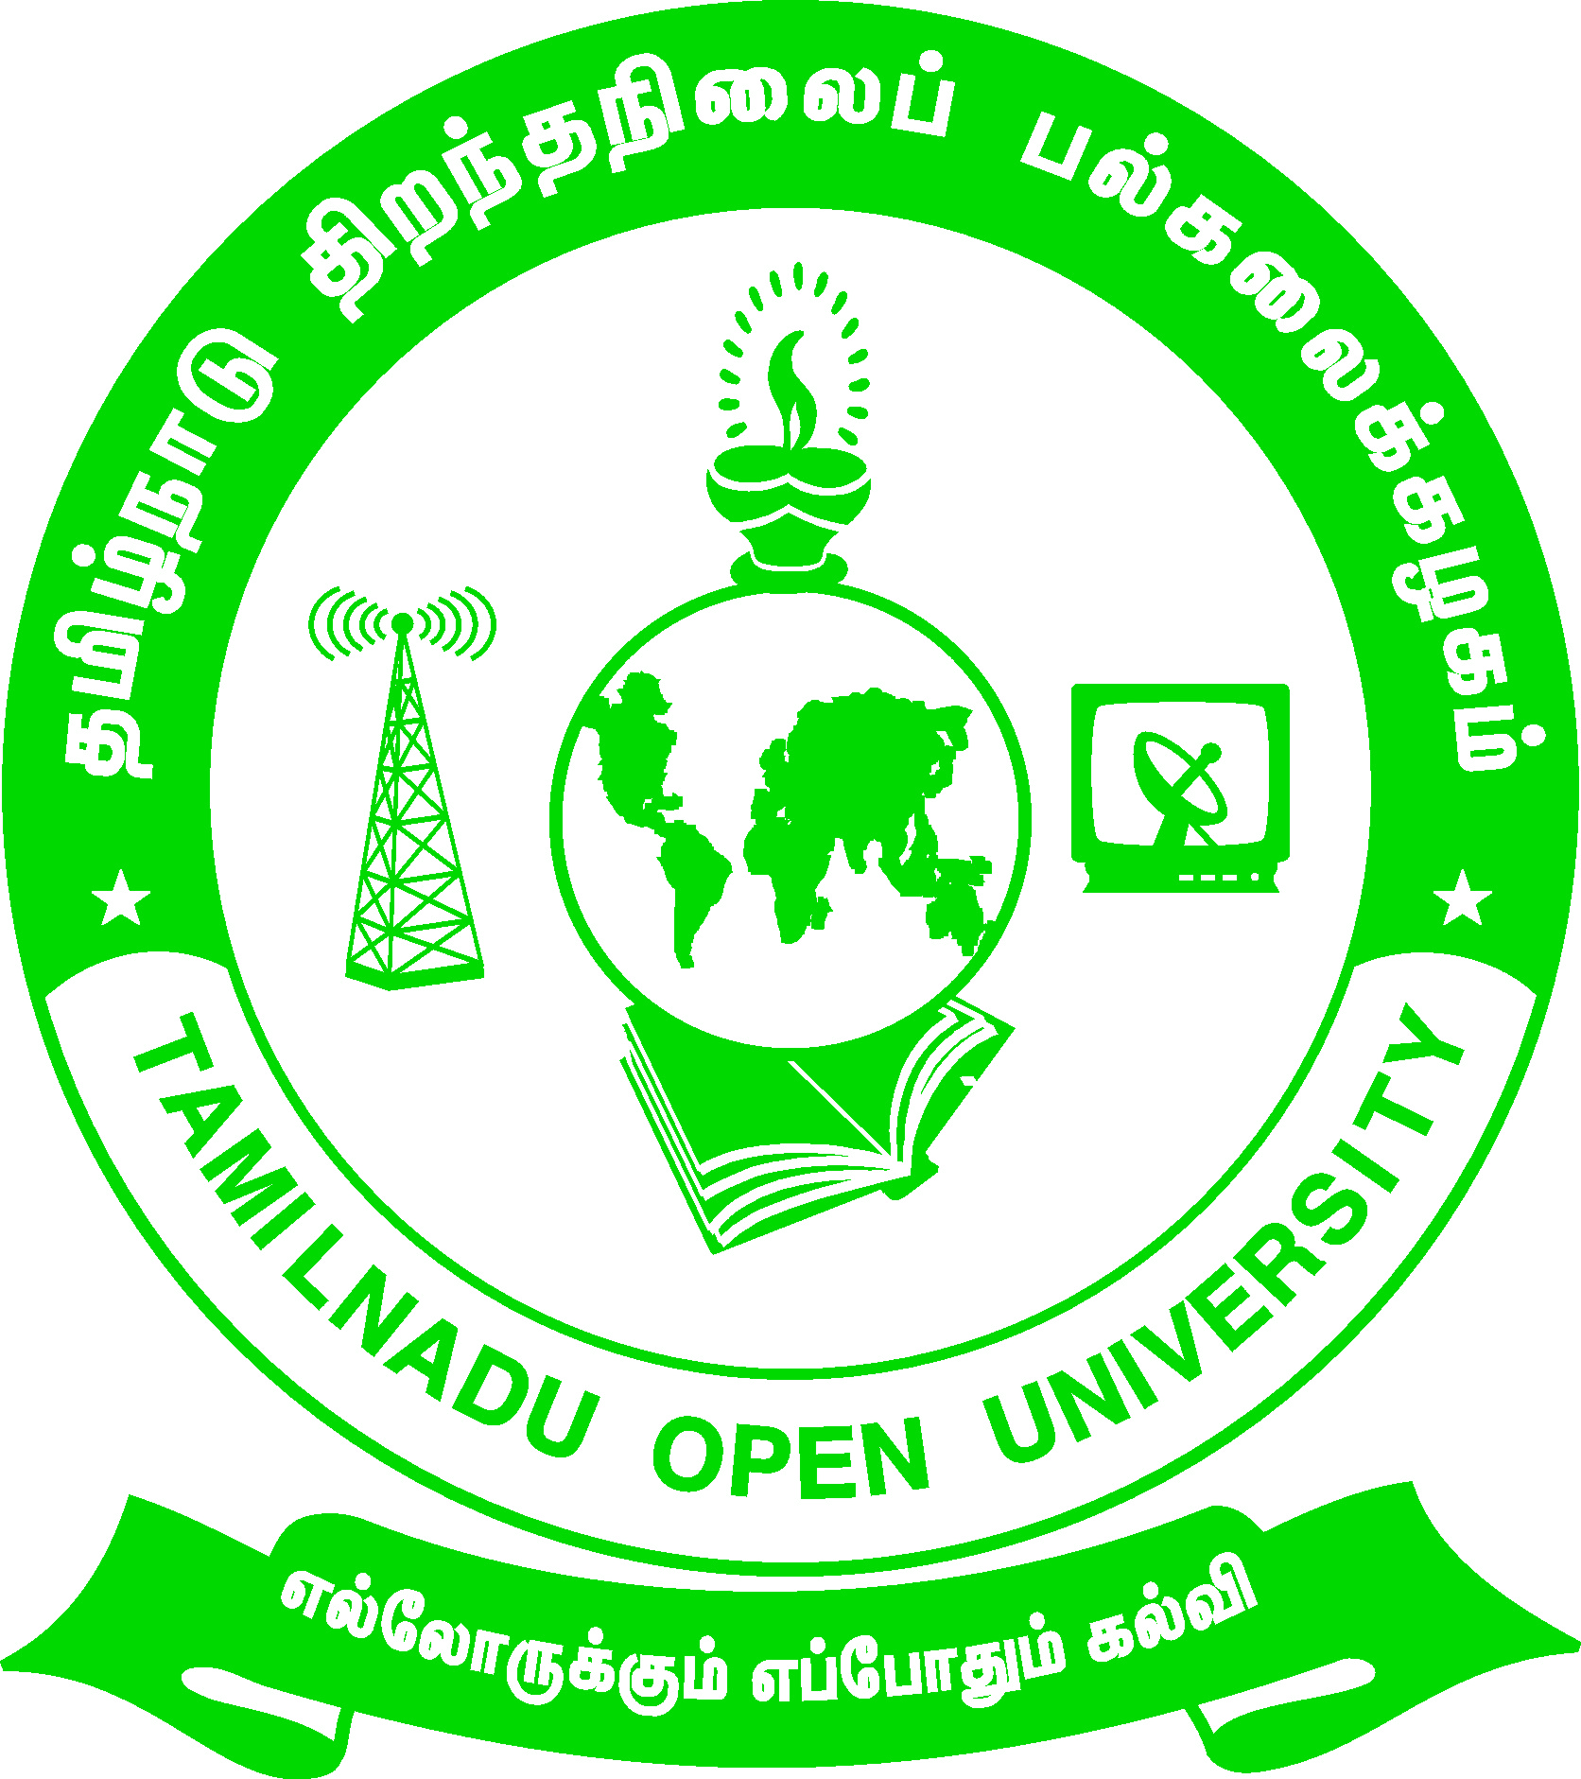 | Tamil Nadu Open University  School of Continuing Education  Chennai – 15
Name of the Programme– Vocational Diploma in Fashion Design and Garment Making - Syllabus (Flexible Skill Training Mode)
Course Title | : | Basic Garment Construction
Course Code | : | VDFG-1
Course Credit | : | 4
Course Objectives

While studying the Basic Garment Construction, the student shall be able to:
- Comprehend the history of sewing machine and the parts of machine
- Detail about the garment details like tucks, pleats, darts etc.
- Explain the process of binding and facing
- Describe about closures, fasteners, pockets, collar and its types
Course Outcomes
After completion of the Basic Garment Construction, the student will be able to:
- Demonstrate the basic stitches used for garment construction
- Work on different neckline finishes
- Comprehend about the various types of fasteners, sleeves, collars
- Create yoke design
Block-1: Basic Stitches and Garment Details
Unit-1: Sewing Machine and Basic Stitches
History of Garment Construction - Sewing Machine - Basic Stitches – Seams - Seam Finishes - Hems
Unit-2: Garment Details
Garment Details - Darts - Tucks – Pleats - Gathers and Shirring - Frills or Ruffles – Flares - Godets
Block-2: Facing, Binding and Openings in Garment Construction
Unit-3: Facing and Binding
Preparation of uses of true bias strip - Cutting of Bias Strips - Joining bias strips Uses of bias strip - Different methods of Neckline Finishing – Facing - Binding

Unit-4: Plackets and Openings
Plackets - Standards of a good placket - Types of Placket - Inconspicuous Placket - Conspicuous plackets
Block-3: Closures, Fasteners and Sleeves
Unit-5: Closures and Fasteners
Fasteners – Buttons - Button Holes - Hooks and Eyes - Button Loops – Snaps - Fancy Buttons – Zippers – Elastics - Tapes and Cord – Velcro - Buckle
Unit-6: Sleeves
Sleeve - Sleeve types - set-in-sleeves - Modified armhole - Sleeve and bodice combined - Two Piece Sleeve
Block-4: Yokes, Collars and Pockets
Unit-7: Yokes
Yoke - Selection of Yoke - Creating Yoke Design - Preparing Patterns for Different types of Yoke - Partial Yoke - Midriff Yoke
Unit-8: Collars and Pockets
Collar - Type of collar – Pocket - Types of Pocket

Tamil Nadu Open University
School of Continuing Education
Chennai – 15
Name of the Programme– Vocational Diploma in Fashion Design and Garment Making - Syllabus (Flexible Skill Training Mode)
Course Title | : | Pattern Making and Grading
Course Code | : | VDFG-2
Course Credit | : | 4
Course Objectives
While studying the Pattern Making and Grading, the student shall be able to:
- Comprehend about taking body measurement for men, women and children
- Describe the pattern making principle and create paper pattern
- Manipulate the darts and convert it into seams
- Explain about grading of patterns
Course Outcomes
After completion of the Pattern Making and Grading, the student will be able to:
- Design and draft pattern of men, women and children garment
- Create and grade a pattern
- Measure and standardize the body measurement
- Construct patterns, relocate dart and do pattern alterations
Block-1: Measurement and Pattern Making
Unit-1: Body Measurement
Body Measurement - Ladies, Men’s and Children’s Measurement - Measurement Taking Method - Standardizing Body Measurement - Relative Length and Girth Measurement
Unit-2: Pattern Making
Pattern Making - Paper pattern - Principles of Pattern Drafting - Pattern Drafting for Children’s and Adults
Block-2: Pattern Grading, Layout and Cutting
Unit-3: Pattern Grading
Pattern Grading - Grading Technique - Principles of Pattern Drafting - Pattern Drafting for Children’s and Adults
Unit-4: Pattern Layout, Marking and Cutting
Preparation of Fabric for sewing - Pattern Layout - Pattern Marking - Pattern cutting
Block-3: Pattern Alterations and Child Garment Construction
Unit-5: Relocation of Darts and Pattern Alterations
Dart Manipulation - Shifting Blouse Dart to new position - Slash and Spread Method - Converting Darts to Seams - Incorporating dart into a seam - Pattern Alteration - Pattern alteration for figure irregularities
Unit-6: Design and Draft for Children’s Garment
Children’s garment – Bib - Panty - Jabla – Babasuit - A-line petticoat - Summer Frock - Yoke Frock - Knicker - Shirt
Block-4: Designing and Drafting of Women and Men’s Garment
Unit-7: Design and Draft for Women’s Garment

Women’s Garment - Saree Petticoat - Middi skirt - Middi top - Saree blouse – Salwar – Kameez – Nightie - Ladies pant
Unit-8: Design and Draft for Men’s Garment

Men’s garment - Slack shirt - Nehru Kurtha – Pyjama – churidhar - Pleated Trousers - T-Shirt - Bermudas

Tamil Nadu Open University
School of Continuing Education
Chennai – 15
Name of the Programme– Vocational Diploma in Fashion Design and Garment Making - Syllabus (Flexible Skill Training Mode)
Course Title | : | Fashion Designing and Embroidery
Course Code | : | VDFG-3
Course Credit | : | 4
Course Objectives
While studying the Fashion Designing and Embroidery, the student shall be able to:
- Comprehend about the terminologies used in Fashion industry
- Describe about the Elements and Principles of Design
- Explain about various types of trimmings and decorations
- Understand about the basic tools used for embroidery
- Brief about the various traditional embroideries of India
Course Outcomes
After completion of the Course Fashion Designing and Embroidery, the student will be able to:
- Explain about the different types of Design
- Demonstrate the various surface ornamentation work
- Competent in use of colours in designing
- Perform the various traditional embroideries of India
Block-1: Fashion Industry and Design
Unit-1: Fashion Industry Terminology
Terms Related to Fashion industry - Basic terms - Industry Terms - Designer Terms
Unit-2: Design and Elements of Design
Design - Types of Design - Elements of design
Block-2: Fashion Decorations and Principles of Design
Unit-3: Trimmings and Decorations
Trimmings and Decoration - Trimmings and Decoration Types - Fastening -Bias Trimming – Fullness - Decorative stitches - Edge finishing &Decoration - Lace, Ric Rac, Braid - Surface Work - Surface Ornamentation - Fashion Accessories
Unit-4: Principles of Design
Principles of Design – Harmony – Balance – Rhythm – Emphasis - Proportion
Block-3: Colour and Embroidery
Unit-5: Colour
Colour - Properties of Colour/ Colour Dimensions - Colour Theories/Chart - Colour Schemes - Colour Psychology - Warm and Cool Colours - Use of colour in designing - Visual effects of colour in dress
Unit-6: Embroidery
Embroidery - Tools and Equipment - Preparation step for Embroidery Work - General Rules for Hand Embroidery Stitch - Hand Embroidery Stitch
Block-4: Traditional Embroideries of India
Unit-7: Traditional Embroideries of India - I
Traditional Indian embroidery - Kashida of Kashmir embroidery - Phulkari of Punjab - Embroidery Gujarat
Unit-8: Traditional Embroideries of India - II
Embroidery of Rajasthan - Kasuti work of Karnataka - Chicken work of Lucknow - Kantha of Bengal

Tamil Nadu Open University
School of Continuing Education
Chennai – 15
Name of the Programme– Vocational Diploma in Fashion Design and Garment Making - Syllabus (Flexible Skill Training Mode)
Course Title | : | Garment Construction(Practical)
Course Code | : | VDFG-P1
Course Credit | : | 4
Choose the material for your design – prepare the Pattern-laying, marking, cutting & Construct the Any Five Of the following children’s garment - Calculate the cost of the garment.
- Bib, Panty
- Jabla
- Babasuit or romper
- A-line petticoat or Summer Frock
- Yoke Frock
- Knicker, Shirt
Choose the material for your design – prepare the Pattern-laying ,marking, cutting & Construct the Any Five Of the following Women’s garment - Calculate the cost of the garment
- Saree Petticoat
- Middi, Middi top
- Saree blouse
- Salwar
- Kameez
- Nightie
- Ladies pant
Choose the material for your design – prepare the Pattern-laying ,marking, cutting & Construct the Any Five Of the following Men’s garment - Calculate the cost of the garment
- Slack shirt
- Nehru kurtha
- churidhar
- Pyjama
- Pleated trousers
- T-Shirt
- Bermudas

Tamil Nadu Open University
School of Continuing Education
Chennai – 15
Name of the Programme– Vocational Diploma in Fashion Design and Garment Making - Syllabus (Flexible Skill Training Mode)
Course Title | : | Fashion Designing and Embroidery(Practical)
Course Code | : | VDFG-P2
Course Credit | : | 4
Drawing Diagrams or samples for the following:
- structural and decorative design
- Elements of design – line, shape or form, colour , size and texture.
- Application of structural and decorative design in a dress
- Principles of design- balance – formal and informal, rhythm- through repetition, radiation and gradation, emphasis, harmony and proportion
- colour theories- prang colour chart and munsell colour system
- Dimensions of colour- hue, value, and intensity.
- Colour in principles of design- application of the same in dress design.
Embroidery
Prepare samples for the following
- Hand Embroidery Stitches-Any 20 samples
- Traditional Embroidery stitches
- Embroidery of Kashmir
- Phulkari of Punjab
- Gujarat – Kutch and Kathiawar
- Embroidery of Rajasthan
- Kasuti of Karnataka
- Chicken work of Lucknow
- Kantha of Bengal

Tamil Nadu Open University
School of Continuing Education
Chennai – 15
Life Coping Skills (LCS) and Communication Skills (CNS)-Core Course for all Vocational Diploma Programmes
Life Coping Skills and Communication Skills have been included to help the students to understand the meaning of life and to understand the meaning of relationship and how we communicate in every day life.
Examination System: Examination to Life Coping Skills and Communication Skills are designed to maintain quality of standard. Theory will be conducted by the University in the identified Examination Centres. For the Spot Assignment students may be permitted to write with the help of books/materials for each Course, which will be evaluated by the Evaluators appointed by the University.
Assignment (Internal): Assignment carries 30 marks, consists of descriptive type of questions for each Course (3 X 10 = 30 Marks). Learners are expected to write 10-15 pages for each assignment. Submission of Assignment is compulsory.
Theory Examination (External): Students shall normally be allowed to appear for Theory Examination by completing Practical and Assignment. The Term-End Examination shall carry Section- A, Section- B and Section- C
Section-A | Three out of Five Short Answer Questions [Each 3- Marks] | 3 X 3 = 9 Marks
Section-B | Three out of Five Long Answer Questions [Each 7- Marks] | 3 X 7 = 21 Marks
Section-C | Four out of Seven Essay questions of which one will be Multiple Choice Question  [Each 10-marks] | 4 X 10 = 40 Marks
Total |  | 70 Marks
Passing Minimum: The passing minimum is 35 percent in the internal and external/ theory examination taken together for successful completion of each course.

Tamil Nadu Open University
School of Continuing Education
Chennai – 15
Name of the Course – Life Coping Skills - Syllabus (Flexible Skill Training Mode)
Course Title | : | Life Coping Skills
Course Code | : | LCS
Course Credit | : | 6
(1).Life Coping Skills : The main objectives of the Life Coping skills is to understand the meaning of life and its challenges, provide skills and knowledge needed to cope with life’s problems and challenges, develop a positive attitude, train to be successful and useful citizens through positive thinking, cope with criticism, failure, anger, loneliness, physical and verbal abuse, improve self-esteem, manage time and stress, develop one’s personality to its full potential, help the students to become team players, develop personal skills and to provide skill problems solving and decision making.
Block- 1-Self Skills
Unit-1: Self Skill – I
Meaning and Process of Coping- Restructuring the Life Story - External and Internal Influences in One's Life - Messages: Positive and Negative - Life Illustrations - Self Esteem - Self Concept - Self Acceptance - Self Actualisation- Personality Development
Unit-2: Self Skill – II
Positive Thinking - Goal Setting - Problem Solving - Decision Making
Block- 2: Social and Leadership Skills
Unit-3: Social Skills
Social Skills- Motivation- De-motivating Factor- Meaning and Attitude to Success- Time Management -The Management of Time is the Management of Life - How to gain an extra mile every day- Tips for Time Management - Stress Management
Unit-4: Leadership Skills
Emergence of a Leader -Characteristics of Leadership -Various kinds of Leaders -What should Leader do- The Moulding of a Leader - Characteristics of a Successful Leader- Team Work - What is it like work in a Team- What is Team Learning
Unit-5: Coping Skills – I
What is Shyness- How to Overcome Shyness- Tips to Overcome Shyness - Coping with Loneliness-Finding Ways to Change the Feelings of Loneliness-Overcoming Loneliness - Tips to Overcome Loneliness- Coping with Depression - Coping with Fear- Coping with Anger and Verbal Abuse -Verbal Abuse- Coping with Failure - Coping with Criticism
Unit-6: Coping Skills – II
Coping with HIV – AIDS- Coping with Alcoholism - Tobacco and Smoking - Coping with Substance Abuse
Block -4: Managerial and Entrepreneur Skills
Unit-7: Managerial Skills
Coping with Conflict- Conflict can be Constructive or Destructive- Constructive Nature of Conflicts- What are the Strategies for Managing Conflicts- Tactics of Conflict Management- Coping with Change- Twelve Steps to Implement Change
Unit-8: Entrepreneur Skills
Career Guidance - Career Planning- Preparation for Employment- Looking for Opportunities - Preparation for the Interview - Work Environment - Thriving in Today's Work Environment .

Tamil Nadu Open University
School of Continuing Education
Chennai – 15
Name of the Course – Communication Skills - Syllabus (Flexible Skill Training Mode)
Course Title | : | Communication Skills
Course Code | : | CNS
Course Credit | : | 6
(2).Communication Skills: The main objectives of the Communication Skills is to introduce to the students the process and kinds of communication, train the students to code and decode communication effectively, explain the various interpersonal skills required to interact with others and make the students understand the meaning of relationship and how we communicate in every day life.
Block -1: Communication
Unit-1: Introduction to Communication
Communication concept- Process of Communication- Elements of Communication- Types of Messages- Types of Communication- Speech- Different Types of Verbal Communication-Effective Communication-Interpersonal Communication- Communication as Skilled Behaviour-Social Skills Model- Social Skills Model to Interpersonal Communication-Implications of the Approach-Components of Interpersonal Skills-Characteristics of a Good Conversation-Hints for Inter-Personal Relation-Ship
Unit-2: Effective Communication
Definition of Effective Communication- Common Forms of Communication- The Positive Value of Good Communication- Guidelines for Effective Communication- Review Questions- Three Principles of Communication- Communication Strategies
Block- 2:Situational and Behavioural Communication
Unit-3: Situational Language
Greeting and Introducing- Inviting Someone and Making Requests- Offering Help and Seeking Permission- Asking for Advice and Expressing Gratitude-Asking whether Someone Remembers- Persuading, Complimenting and Congratulating- Expressing Sympathy- Complaining and Apologising- Making Suggestions and Warning Someone- Asking for Excuse and Ending a Conversation- Asking for Information and Someone's Opinion- Asking if someone is sure and to Say Something Again- Checking that you have understood- Asking whether someone knows- Asking About Possibility and Preference- Requesting Someone- Asking if someone Agrees- Asking if someone is Obliged to do something- Some Useful Expressions- Different Models of Situational Conversations
Unit-4: Behavioural Communication
Effective Criticism Made Easy: Basic Rules for Delivering-Negative Feedback to Others- Before Delivering to Negative Feedback- While Delivering Negative Feedback- After Delivering Negative Feedback
Block -3: Types and Modes of Communication
Unit-5: Modes of Communication
Group Discussion- Importance of Group Testing- Factors that Contribute to Group-Worthiness- Guidelines for Group Discussion- Factors that Matter in a Group Discussion- Important Parameters in Group Discussion- Types of Groups- Speech- Speech Distractions- Five ways to make your Audience Sit Up- Successful Public Speaking- Drafting a Speech- Major Pitfalls in Public Speaking- Body Language- The Constituents of Body Language
Unit-6: Leadership and Team Communication
Definition of a Leadership- Types of Leadership- Shared Leadership- Ten Principles for Leadership Communication- Styles of Leadership- Team Communication- Achieving Effectiveness through Team Communication- The Components of Communication- Characteristics of Highly Cohesive Teams
Block- 4:Interview Skills and English Language
Unit-7: Interview Skills
Interview Defined- Kinds of Interviews- Preparation for a Job Interview- Telephonic Interview- Preparation for a Telephonic Interview- Speaking to Foreigners- Success in Interview-Ten Most Frequently Asked Questions- Inter Whew- Inter Phew
Unit-8: English as Spoken and Written Language
Simple Sentence- Word Order- Modals- Passive Voice- Letter Writing-An Informal Letter-Formal Letter-Personal Letters- Official Letters- Paragraph Writing- Essay Writing- Types of Essay- Prose Comprehension- Poetry Comprehension- Precise Writing- Dialogues.

