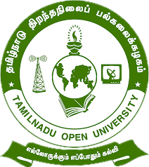

Tamil Nadu Open University
School of Continuing Education

jkpo;ehL jpwe;jepiyg; gy;fiyf;fofk;
njhlh; fy;tpf;fhdg; gs;;sp

Programme Project Report (PPR)

Vocational Diploma in Catering Assistant (VDCA)

Members of the Board of Studies [BOS]
of School of Continuing Education

S.No. | Name | Designation
1 | Dr. P. Thiyagarajan | Professor & Director  School of Continuing Education  Tamil Nadu Open University,  Chennai
2 | Dr. K. Devan | Professor & Centre Head  Centre for Adult and Continuing Education,  Pondicherry University,  R.V. Nagar, Puducherry
3 | Dr. V.P. Matheswaran | Professor & Head  Department of Adult & Continuing Education,  University of Madras,  Chepauk, Chennai
4 | Dr. S. Jayalakshmi | Assistant Professor  DDU-KAUSHAL Kendra,  Bharathidasan University,  Tiruchirappalli
5 | Mr.S.Vendan | Managing Director  Vendan Visual Effects,  Thirvanmiyur, Chennai
6 | Ms.C.Rohini Chandrasekaran | Consultant  Fair Labour Associations,  Tirupur, Tamil Nadu
7 | Mr. R. Thiyagarajan | Junior Instructor  IIDA Community College,  No.38,Bharathi Nagar Main Road,  Zamin Pallavaram, Chennai
8 | Mrs. V. Rubini | Nurse, Health Centre  Tamil Nadu Open University, Chennai
9 | Er. R. Meenambigai | Assistant Professor  School of Continuing Education  Tamil Nadu Open University,  Chennai
10 | Dr. I. Ambeth | Assistant Professor & Regional Director i/c  Madurai Regional Centre,  Tamil Nadu Open University,  Madurai

Tamil Nadu Open University
School of Continuing Education
Vocational Diploma in Catering Assistant (VDCA)
Programme Project Report (PPR)
(a). Programme’s Mission & Objectives: The main Objectives of the Vocational Diploma in Catering Assistant Programme is to train the learners for the job of Assistant chef, cook, kitchen worker in hotel, Food production industry, cutting of vegetables, non-vegetarian foods, preparation of bakery items and confectionery products and also building the key competencies amongst the learner.
(b).Relevance of the Programme with HEI’s Mission and Goals: Tamil Nadu Open University one of Mission and Goal is to encourage Skill Development to empower the human resource through Participatory Education System and accordingly the Vocational Diploma Programme has been developed. The Programme is being offered under flexible skill training mode.
(c). Nature of prospective target group of learners: Candidates who wish to seek employment in the hospitality industry or become an entrepreneur particularly the young boys/ girls, slum dwellers, unskilled workers employed in the mechanic field, rural dwellers, unemployed youths and minorities.
(d). Appropriateness of programme to be conducted in Open and Distance Learning mode to acquire specific skills and Competence: Apart from ODL Mode, the Programme also has been designed to offer under Flexible Skill Training mode. Catering Assistant persons are to cook a variety of Indian cuisines, prepare bakery items like breads, buns, cakes and pastries. To acquire Specific Skill, the Core Skills, Generic Skills and Professional Skills component are also included.
(e). Instructional Design: The Curriculum and the Syllabi are designed by covering all the aspect of cooking and menu. The duration of the Programme is One Year and it will be offered both English and Tamil Medium. Required Faculties working in the Community Colleges will handle classes for the Vocational Diploma Programme in Catering Assistant. The Programme will be delivered through Community Colleges of Tamil Nadu Open University which is having required faculties and support staff. The Credit System suggested by Distance Education Bureau i.e., 32 Credits for One Year Diploma has been assigned. Print, Audio and Video materials also will be developed for the Programme.
(f).Procedure for Admissions, Curriculum Transaction and Evaluation: The admission for the Catering Assistant Programme will be carried out through on-line by Tamil Nadu Open University and the Counselling and Practical classes will be conducted through Constituent Community College and Community Colleges of Tamil Nadu Open University. The hands on training will be provided in the Industries and mobile Lab. The evaluation will be carried by Tamil Nadu Open University consists of Continuous Internal Assessment through Spot Assignment and External Assessment through Term End Examination.
(i).Eligibility: Candidates who have passed in the 10th Standard Examinations or its equivalent as per Tamil Nadu Government Order No-163 dated 22-05-2008.
(ii).Fee Structure: Rs.4,200/- (plus Registration Charges)
(g) Requirement of the laboratory support and Library Resources: Lab Facilities are made available in Constituent Community Colleges and Community Colleges of Tamil Nadu Open University as per requirement as given in the National Skill Development Corporation(NSDC), Qualification Pack(QP). Practical Manual developed by the Tamil Nadu Open University will be supplied to the Students apart from Self Learning Materials. Library Books are available at the Headquarters, Regional Centres and Constituent Community Colleges and Community Colleges of Tamil Nadu Open University.
(h). Quality Assurance Mechanism and Expected Programme Outcomes:Tamil Nadu Open University through its Centre for Internal Quality Assurance (CIQA) will monitor the delivering aspect of Constituent Community Colleges and community Colleges of TNOU for maintaining quality. Feedback will be collected from the Learners and success story if any will also be shared with learners. After completion of Catering Assistant Programme, Learner will acquire the Core Skills, Generic Skills and Professional Skills components and will be employed in the automobile Industry.
Proposed Programme Structure of Vocational Diploma in Catering Assistant
S.No | Course Code | Course Title | Credits | Marks Distribution
 |  |  |  | Internal | External | Total
1 | VDCA-1 | Food and Kitchen | 4 | 30 | 70 | 100
2 | VDCA-2 | Food Production | 4 | 30 | 70 | 100
3 | VDCA-3 | Indian Cuisines, Bakery and Confectionery | 4 | 30 | 70 | 100
4 | VDCA-P1 | Food Production (Practical) | 4 | 30 | 70 | 100
5 | VDCA-P2 | Indian Cuisines, Bakery and Confectionery (Practical) | 4 | 30 | 70 | 100
6 | LCS | Life Coping Skills | 6 | 30 | 70 | 100
7 | CNS | Communication Skills | 6 | 30 | 70 | 100
Total |  |  | 32 | 210 | 490 | 700
Age: 15 years and above
Duration of Programme: 1 year and maximum of 3 years
Credits: Credits in Open and Distance Learning (ODL) is nothing but study hours. The following are explanation for Credit in ODL System.
- One Credit would mean equivalent of 30 hours of study.
- Learners are expected to allot 24 hours for reading the Self Learning Materials supplied by the University, 3 hours for viewing the video and listening the audio and 3 hours for writing assignments to complete one credit in ODL.
Examination System: Examination to Vocational Diploma Programme in Catering Assistant is designed to maintain quality of standard. Theory will be conducted by the University in the identified Examination Centres. For the Spot Assignment students may be permitted to write with the help of books/materials for each Course, which will be evaluated by the Evaluators appointed by the University.
Assignment (Internal): Assignment carries 30marks, consists of descriptive type of questions for each Course (3 X 10 = 30 Marks). Learners are expected to write 10-15 pages for each assignment. Submission of Assignment is compulsory.
Theory Examination (External): Students shall normally be allowed to appear for Theory Examination by completing Practical and Assignment. The Term-End Examination shall carry Section- A, Section- B and Section- C
Section-A | Three out of Five Short Answer Questions [Each 3- Marks] | 3 X 3 = 9 Marks
Section-B | Three out of Five Long Answer Questions [Each 7- Marks] | 3 X 7 = 21 Marks
Section-C | Four out of Seven Essay questions of which one will be Multiple Choice Question  [Each 10-marks] | 4 X 10 = 40 Marks
Total |  | 70 Marks
Passing Minimum: The passing minimum is 35 percent in the internal and external/ theory examination and overall 40 per cent for successful completion of each course.
Classification of Successful Candidate: Candidates who pass all the Courses and who secure 60 per cent and above in the aggregate of marks will be placed in the First Class. Those securing 50 per cent and above but below 60 per cent in the aggregate will be placed in the Second Class. Those securing 40 per cent and above but below 50 per cent in the aggregate will be placed in the Third Class.

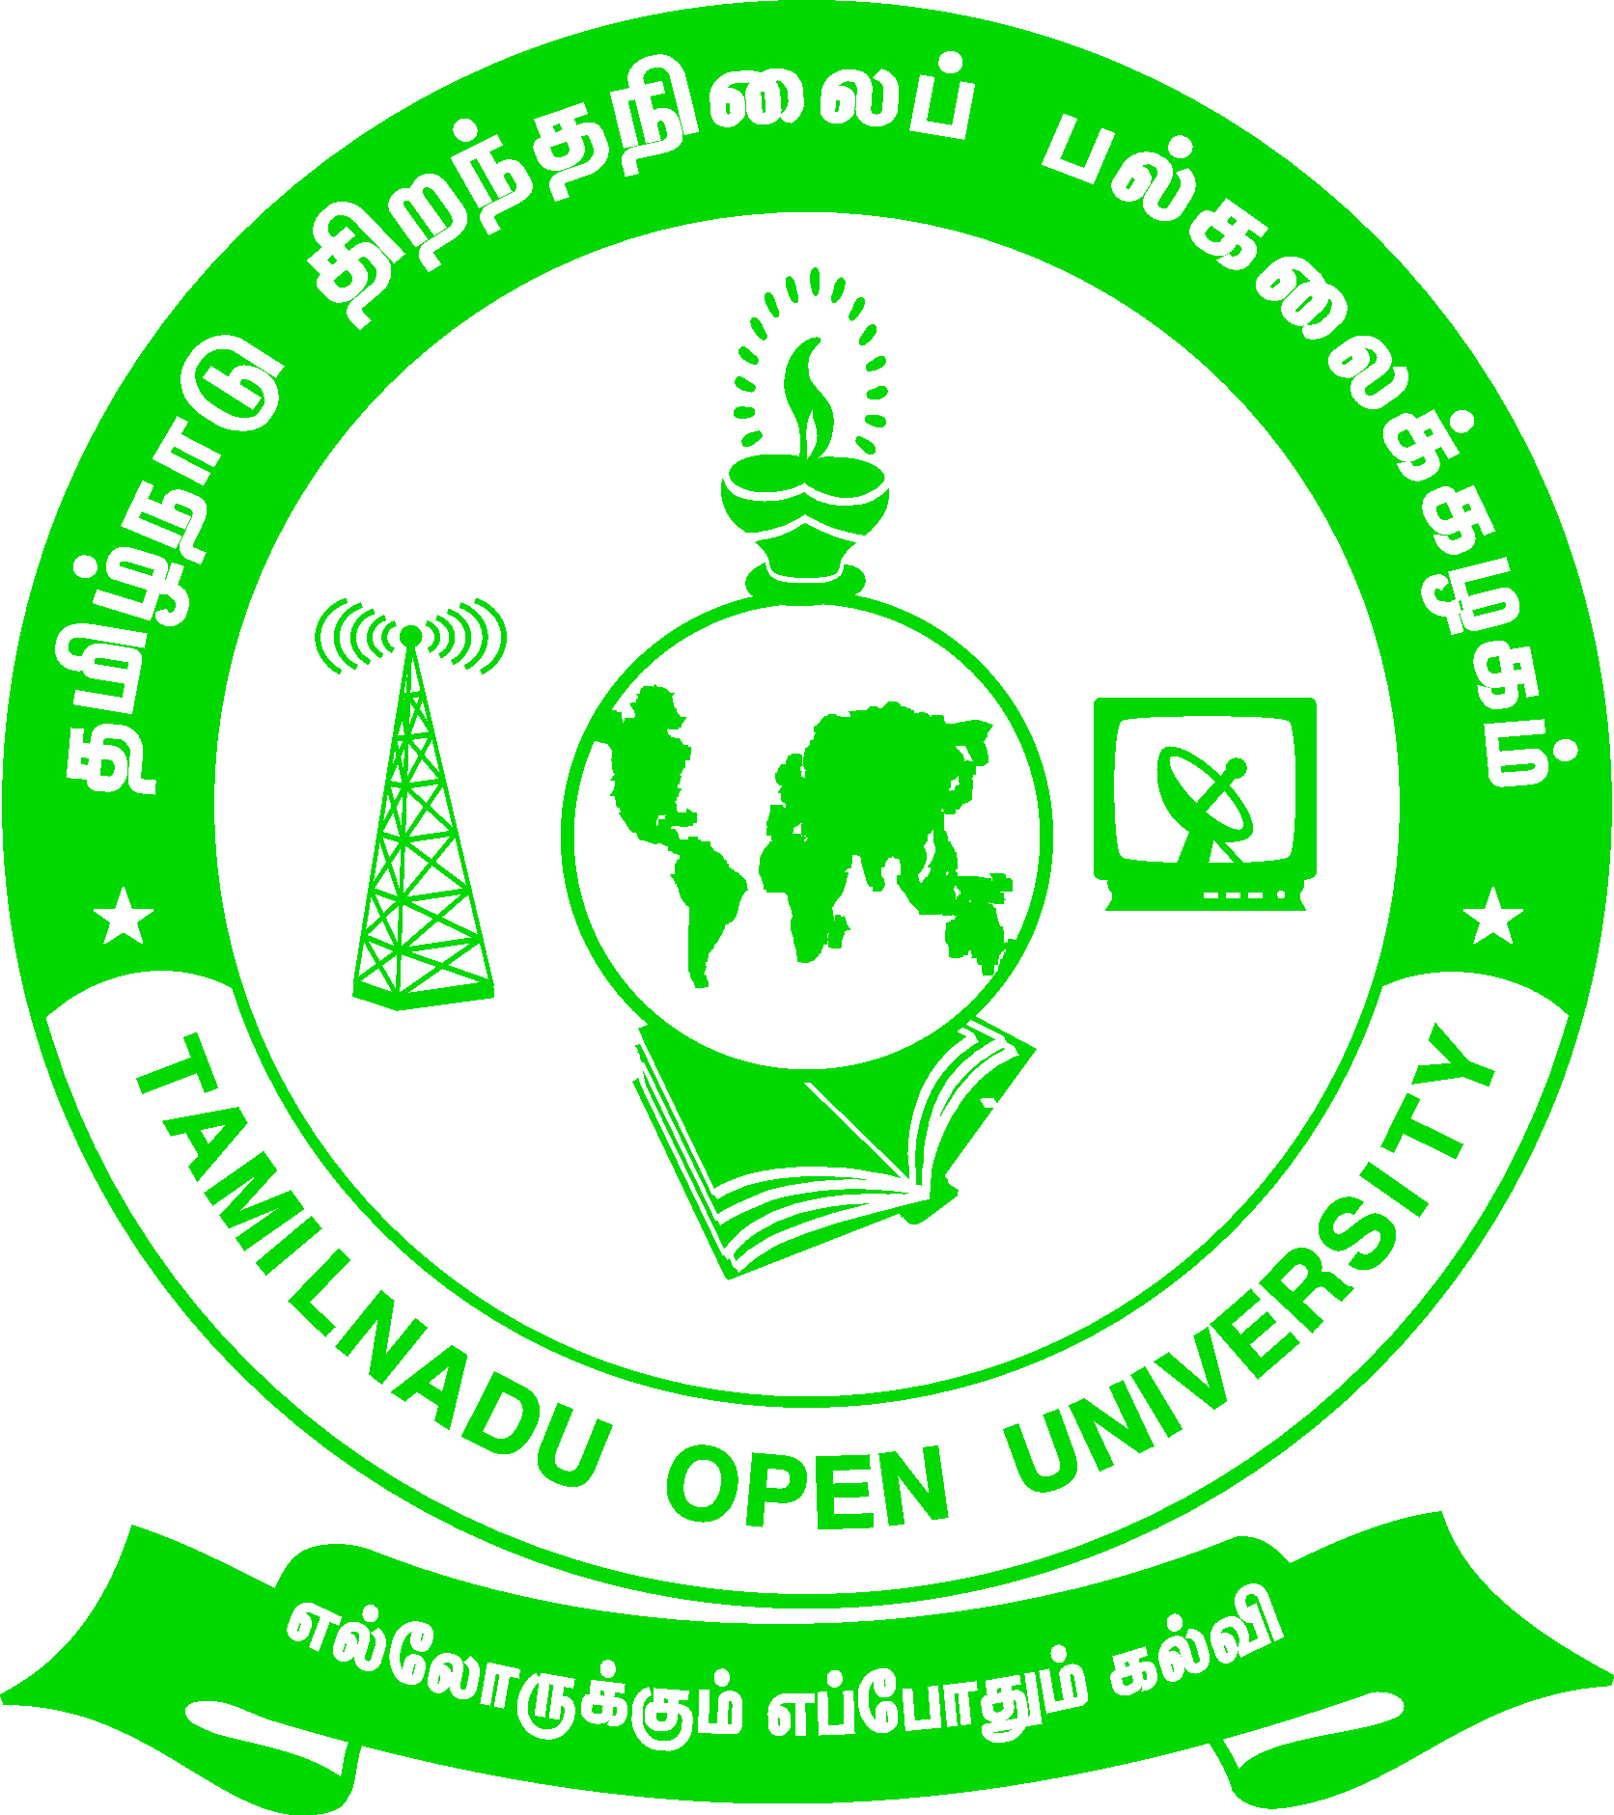 | Tamil Nadu Open University  School of Continuing Education  Chennai – 15
Name of the Programme– Vocational Diploma in Catering Assistant - Syllabus (Flexible Skill Training Mode)
Course Title | : | Food and Kitchen
Course Code | : | VDCA-1
Course Credit | : | 4
Course Objectives
While studying the Food and Kitchen, the student shall be able to:
- Explain about the Kitchen space and the Hygiene maintenance
- Describe the various cooking materials involved in cooking
- Visualize and know about the Organization of a kitchen and the equipments used in the cook space
Course Outcomes
After completion of the Course Food and Kitchen, the student will be able to:
- Describe the origin of modern cookery
- State the aims and objectives of cooking food
- Demonstrate various ingredient preparation methods
- Understand the hierarchy of chefs and other in the kitchen
Block - 1: Introduction to Kitchen and Cookery
Unit-1: Kitchen and Personal Hygiene
Origins of modern cookery - Personal Hygiene - Cleanliness of surface - Garbage Disposal
Unit-2: Introduction to Cookery
Aims and Objectives of cooking Food - Various textures and consistencies - Techniques used in pre-preparation - Techniques used in preparation
Block- 2: Various Cooking Materials
Unit-3: Cooking Materials - I
Foundation ingredients– Meaning - Action of heat on carbohydrates, fats, proteins, minerals and vitamins - Fats and oils – Meaning and examples of fats and oils - Hydrogenation of oils, uses of fats and oils - Commonly used fats and oils, their sources and uses - Raising agents – Functions of raising agents - Chemical raising agents and yeast
Unit-4: Cooking Materials - II
Eggs– Uses of egg in cooking - Characteristics of fresh eggs, storage of eggs - Salt – Uses - Liquids - uses of a liquid - Flavorings and seasonings – Uses - Sweetening agents – Uses - Thickening agents - Condiments & spices - Herbs – Uses of herbs
Block – 3 : Ingredients Preparation and Cooking the Food
Unit-5: Preparation of Ingredients
Washing, Peeling and scraping - Pairing, cutting and grating - Grinding and mashing - Other Preparation Methods - Methods of mixing food
Unit-6: Transfer of Heat to Food
Magnetron waves meaning - Methods of Cooking Food - Principle behind each method of cooking - Care and precautions in Selection of food for each type of cooking
Block-4: Kitchen Organization and Equipments
Unit-7: Kitchen Organization
Hierarchy Area of Department and Kitchen - Classical Brigade - Modern staffing in various category hotels - Roles of executive chef - Duties and responsibilities of various chefs - Co-ordination of food production department with other departments
Unit-8: Kitchen Equipments
Classification of kitchen equipment - Uses of Equipments - Ancillary Equipments - Cooking fuels - Uses and advantages of different cooking fuels

Tamil Nadu Open University
School of Continuing Education
Chennai – 15
Name of the Programme– Vocational Diploma in Catering Assistant - Syllabus (Flexible Skill Training Mode)
Course Title | : | Food Production
Course Code | : | VDCA-2
Course Credit | : | 4
Course Objectives
While studying the Food Production, the student shall be able to:
- Describe about the various food commodities
- Prepare stocks and Sauces
- Demonstrate the cutting of vegetables and fruits
- Expertise in egg and non-vegan cookery
Course Outcomes
After completion of the Course Food Production, the student will be able to:
- Explain the preparation of stocks and Sauces
- Demonstrate the cutting of all variety of non-vegetarian food
- Gain knowledge about Larder
- Prepare many varieties of Salads and Sandwiches
Block -1: Food Commodities and Production
Unit-1: Food Commodities
Introduction - Classification and identification of Food Commodities - Structure of wheat and Types - Types of Flour - Milk - Pasteurization – Homogenization - Cream- Processing of Cream and Types - Yoghurt – types and uses - Ice cream –production of ice cream
Unit-2: Principles of Food Production
Stocks - Types of stock - Preparation of stock - Storage and uses of stock - Sauces-Classification of sauces - Recipes for mother sauces - Consommés, Garnishes and accompaniments
Block – 2: Vegetable, Fruit and Egg Cookery
Unit-3: Vegetable and Fruit Cookery
Classification of vegetables - Pigments and colour changes - Effects of heat on vegetables - Classification of fruits - Uses of fruit in cookery - Salads and salad dressings
Unit-4: Egg Cookery and Cooking of Pasta
Introduction to egg cookery - Selection of egg - Uses of egg in cookery - Methods of cooking egg - Pasta – classification - Types, names of various pasta’s - Cooking of pasta’s
Block- 3: Non-Vegetarian Cookery, Salads and Sandwiches
Unit-5: Non-Vegetarian Cookery
Fish Cookery - Classification of fish - Cuts of fish - Cooking of fish - MeatCookery - Cuts of beef/veal, Cuts of lamb/muttons, Cuts of pork - Uses of various parts in cooking - Poultry-Types - Cut of Chicken
Unit-6: Salads and Sandwiches
Salads – classification - Salad dressing - Names and recipes for popular salads - Salient features of preparing good salads - Sandwich - Fillings & spreads used - Types of sandwiches - Modern approach to sandwiches in hotels
Block – 4: Planning For Menu and Larder Work
Unit-7: Menu Planning
Points to consider in menu planning - Planning menus for various situation - Principles of Indenting for volume feeding - Modifying recipes for indenting for large scale catering - Principles of planning for quantity food production - Equipment selection and Staffing
UNIT-8: Larder
Essentials of larder control - Importance and functions of larder in main kitchen - Relationship with other section of main kitchen - Duties and responsibilities of Larder chef - Equipments and tools used in larder - Floor plan or layout of a larder

Tamil Nadu Open University
School of Continuing Education
Chennai – 15
Name of the Programme– Vocational Diploma in Catering Assistant - Syllabus (Flexible Skill Training Mode)
Course Title | : | Indian Cuisines, Bakery and Confectionery
Course Code | : | VDCA-3
Course Credit | : | 4
Course Objectives
While studying the Indian Cuisines, Bakery and Confectionery, the student shall be able to:
- Explain the Heritage of Indian Cuisine
- Describe the preparation of Indian Breads like Naan and rotis
- Demonstrate the process and preparation of cookies, pies, cakes and chocolates
- Identify the faults that may happen during the preparation of cakes and rectify the same
Course Outcomes
After completion of the Course Indian Cuisines, Bakery and Confectionery, the student will be able to:
- Prepare delicious Indian regional foods and their masalas
- Attempt the preparation of Indian special sweets and savoury
- Understand the process of baking and the dough preparation process
- Describe the process of making bakery and confectionery products
Block- 1: Indian Cuisines and Breads
Unit-1: Indian Regional Cuisines
Introduction to Regional Indian Cuisine - Heritage of Indian Cuisine - Regional Cuisine of India - Ingredients used, Masalas - Methods of cooking in Indian cuisine - Dishes with recipes
Unit-2: Indian Breads
Introduction to Tandoori cooking - Seasoning of Tandoori pot - Tandoori marination – objectives and importance - Tandoori masalas, ingredient - Tandoori preparations - Classical tikka & kabab
Block -2: Indian Snacks and Introduction to Bakery
Unit-3: Special Indian Dishes
Indian breakfast preparation - Indian snacks and chat preparation - Indian festival dishes
Unit-4: Introduction to Baking
General Information - Conversion tables, temperature for different products - Raw materials used in Bakery - Types of oven used in bakery - Types of dough - Dough making process - Bread faults and their causes
Block -3: Biscuits and Pies
Unit-5: Biscuits
Meaning and preparation Cookies - Production of Cookies, Ice box Cookies, bar Cookies - Production of macaroons, wafers and lace cookies - Baked meringues
Unit-6: Pies
Introduction - Production of pies - Rolling a pie dough and lining pans - Preparation of fillings for pies - Production of fruit pies - Preparation of cream and chiffon - Tarts and tartlets
Block - 4: Cakes, Chocolates and Sugar Confectionaries
Unit-7: Cakes
Cake making methods - Cake formula balance - Common faults in cakes - Cake-decoration - Icings - Different types of Icings - Modern cake decoration with royal icing - Fillings and Glazes
Unit-8: Chocolate and Sugar Confectionery
Liqueur Chocolate - Toffees and boiled sweets - Cold sweets - Savoury goods - Toppings, fillings and piping

Tamil Nadu Open University
School of Continuing Education
Chennai – 15
Name of the Programme– Vocational Diploma in Catering Assistant - Syllabus (Flexible Skill Training Mode)
Course Title | : | Food Production (Practical)
Course Code | : | VDCA-P1
Course Credit | : | 4

Identification of Cooking Equipment and Prepare the Following Dishes
- Rice, Cereals& Pulses Based dishes-any 5(Pongal, Sambar, Rice, RagiPuttu etc.)
- Sauces any 2 type
- Soups- any 2 type
- Egg Cookery-Any 2 type
- Pasta-Any 1 type
- Fish Cookery-Fry, Gravy, meal, Side dishes
- Meat Cookery- Fry, Gravy, meal, Side dishes
- Salads- Veg & Fruit Any 1 type/ Each
- Sandwich- Veg & Fruit Any 1 type/ Each
Regional Indian Cuisine- Prepare any one Dishes From Each Cuisine: Punjab, Kashmir, Bengal, Goa, Maharastra, Parsi, Gujurathi, Uttar Pradesh, Kerala-Malabar, Cheriyan, Christian - Andhra- Hyderabadi cuisine- Tamilnadu – chettinadu, Karnataka cooking in Indian cuisine, Dishes with recipes.
Tandoori cooking-Prepare masalas, marinating & Cooking- chicken, mutton, fish, prawns, cottage cheese- tikka & kabab – Any One
Indian breakfast preparation-popular North and South Indian breakfast prep. With recipes-dosas, idlies, doklas, pathri
Indian snacks and chat preparation-Recipes and method of preparation.
Indian festival dishes- Any five Indian Sweet recipes
Tamil Nadu Open University
School of Continuing Education
Chennai – 15
Name of the Programme– Vocational Diploma in Catering Assistant - Syllabus (Flexible Skill Training Mode)
Course Title | : | Bakery and Confectionery (Practical)
Course Code | : | VDCA-P2
Course Credit | : | 4

Prepare the Following Recipes [Minimum 14 Hours for each exercise]
- Bread Preparation
- Biscuits
- Cookies-Types
- Pie – Fruit Pie
- Cake-base Preparation ,Icings
- Chocolate- Preparation
- Pudding
- Pancakes
In Plant Training- Report submission
The Student under go the 10 days training programme in Pantry Section of the Hotel Industry
- To Plan the Menu for Different Group
- To under Stand the Methods of Production
- Equipment Handling, Care and Cleaning
- Prepare the Report and Submit

Tamil Nadu Open University
School of Continuing Education
Chennai – 15
Life Coping Skills (LCS) and Communication Skills (CNS)-Core Course for all Vocational Diploma Programmes
Life Coping Skills and Communication Skills have been included to help the students to understand the meaning of life and to understand the meaning of relationship and how we communicate in every day life.
Examination System: Examination to Life Coping Skills and Communication Skills are designed to maintain quality of standard. Theory will be conducted by the University in the identified Examination Centres. For the Spot Assignment students may be permitted to write with the help of books/materials for each Course, which will be evaluated by the Evaluators appointed by the University.
Assignment (Internal): Assignment carries 30 marks, consists of descriptive type of questions for each Course (3 X 10 = 30 Marks). Learners are expected to write 10-15 pages for each assignment. Submission of Assignment is compulsory.
Theory Examination (External): Students shall normally be allowed to appear for Theory Examination by completing Practical and Assignment. The Term-End Examination shall carry Section- A, Section- B and Section- C
Section-A | Three out of Five Short Answer Questions [Each 3- Marks] | 3 X 3 = 9 Marks
Section-B | Three out of Five Long Answer Questions [Each 7- Marks] | 3 X 7 = 21 Marks
Section-C | Four out of Seven Essay questions of which one will be Multiple Choice Question  [Each 10-marks] | 4 X 10 = 40 Marks
Total |  | 70 Marks
Passing Minimum: The passing minimum is 35 percent in the internal and external/ theory examination taken together for successful completion of each course.

Tamil Nadu Open University
School of Continuing Education
Chennai – 15
Name of the Course – Life Coping Skills - Syllabus (Flexible Skill Training Mode)
Course Title | : | Life Coping Skills
Course Code | : | LCS
Course Credit | : | 6
(1).Life Coping Skills : The main objectives of the Life Coping skills is to understand the meaning of life and its challenges, provide skills and knowledge needed to cope with life’s problems and challenges, develop a positive attitude, train to be successful and useful citizens through positive thinking, cope with criticism, failure, anger, loneliness, physical and verbal abuse, improve self-esteem, manage time and stress, develop one’s personality to its full potential, help the students to become team players, develop personal skills and to provide skill problems solving and decision making.
Block- 1-Self Skills
Unit-1: Self Skill – I
Meaning and Process of Coping- Restructuring the Life Story - External and Internal Influences in One's Life - Messages: Positive and Negative - Life Illustrations - Self Esteem - Self Concept - Self Acceptance - Self Actualisation- Personality Development
Unit-2: Self Skill – II
Positive Thinking - Goal Setting - Problem Solving - Decision Making
Block- 2: Social and Leadership Skills
Unit-3: Social Skills
Social Skills- Motivation- De-motivating Factor- Meaning and Attitude to Success- Time Management -The Management of Time is the Management of Life - How to gain an extra mile every day- Tips for Time Management - Stress Management
Unit-4: Leadership Skills
Emergence of a Leader -Characteristics of Leadership -Various kinds of Leaders -What should Leader do- The Moulding of a Leader - Characteristics of a Successful Leader- Team Work - What is it like work in a Team- What is Team Learning
Unit-5: Coping Skills – I
What is Shyness- How to Overcome Shyness- Tips to Overcome Shyness - Coping with Loneliness-Finding Ways to Change the Feelings of Loneliness-Overcoming Loneliness - Tips to Overcome Loneliness- Coping with Depression - Coping with Fear- Coping with Anger and Verbal Abuse -Verbal Abuse- Coping with Failure - Coping with Criticism
Unit-6: Coping Skills – II
Coping with HIV – AIDS- Coping with Alcoholism - Tobacco and Smoking - Coping with Substance Abuse
Block -4: Managerial and Entrepreneur Skills
Unit-7: Managerial Skills
Coping with Conflict- Conflict can be Constructive or Destructive- Constructive Nature of Conflicts- What are the Strategies for Managing Conflicts- Tactics of Conflict Management- Coping with Change- Twelve Steps to Implement Change
Unit-8: Entrepreneur Skills
Career Guidance - Career Planning- Preparation for Employment- Looking for Opportunities - Preparation for the Interview - Work Environment - Thriving in Today's Work Environment .

Tamil Nadu Open University
School of Continuing Education
Chennai – 15
Name of the Course – Communication Skills - Syllabus (Flexible Skill Training Mode)
Course Title | : | Communication Skills
Course Code | : | CNS
Course Credit | : | 6
(2).Communication Skills: The main objectives of the Communication Skills is to introduce to the students the process and kinds of communication, train the students to code and decode communication effectively, explain the various interpersonal skills required to interact with others and make the students understand the meaning of relationship and how we communicate in every day life.
Block -1: Communication
Unit-1: Introduction to Communication
Communication concept- Process of Communication- Elements of Communication- Types of Messages- Types of Communication- Speech- Different Types of Verbal Communication-Effective Communication-Interpersonal Communication- Communication as Skilled Behaviour-Social Skills Model- Social Skills Model to Interpersonal Communication-Implications of the Approach-Components of Interpersonal Skills-Characteristics of a Good Conversation-Hints for Inter-Personal Relation-Ship
Unit-2: Effective Communication
Definition of Effective Communication- Common Forms of Communication- The Positive Value of Good Communication- Guidelines for Effective Communication- Review Questions- Three Principles of Communication- Communication Strategies
Block- 2:Situational and Behavioural Communication
Unit-3: Situational Language
Greeting and Introducing- Inviting Someone and Making Requests- Offering Help and Seeking Permission- Asking for Advice and Expressing Gratitude-Asking whether Someone Remembers- Persuading, Complimenting and Congratulating- Expressing Sympathy- Complaining and Apologising- Making Suggestions and Warning Someone- Asking for Excuse and Ending a Conversation- Asking for Information and Someone's Opinion- Asking if someone is sure and to Say Something Again- Checking that you have understood- Asking whether someone knows- Asking About Possibility and Preference- Requesting Someone- Asking if someone Agrees- Asking if someone is Obliged to do something- Some Useful Expressions- Different Models of Situational Conversations
Unit-4: Behavioural Communication
Effective Criticism Made Easy: Basic Rules for Delivering-Negative Feedback to Others- Before Delivering to Negative Feedback- While Delivering Negative Feedback- After Delivering Negative Feedback
Block -3: Types and Modes of Communication
Unit-5: Modes of Communication
Group Discussion- Importance of Group Testing- Factors that Contribute to Group-Worthiness- Guidelines for Group Discussion- Factors that Matter in a Group Discussion- Important Parameters in Group Discussion- Types of Groups- Speech- Speech Distractions- Five ways to make your Audience Sit Up- Successful Public Speaking- Drafting a Speech- Major Pitfalls in Public Speaking- Body Language- The Constituents of Body Language
Unit-6: Leadership and Team Communication
Definition of a Leadership- Types of Leadership- Shared Leadership- Ten Principles for Leadership Communication- Styles of Leadership- Team Communication- Achieving Effectiveness through Team Communication- The Components of Communication- Characteristics of Highly Cohesive Teams
Block- 4:Interview Skills and English Language
Unit-7: Interview Skills
Interview Defined- Kinds of Interviews- Preparation for a Job Interview- Telephonic Interview- Preparation for a Telephonic Interview- Speaking to Foreigners- Success in Interview-Ten Most Frequently Asked Questions- Inter Whew- Inter Phew
Unit-8: English as Spoken and Written Language
Simple Sentence- Word Order- Modals- Passive Voice- Letter Writing-An Informal Letter-Formal Letter-Personal Letters- Official Letters- Paragraph Writing- Essay Writing- Types of Essay- Prose Comprehension- Poetry Comprehension- Precise Writing- Dialogues.

